|  |  |
| --- | --- |
| Class: | 3432 Database Systems |
| Professor: | **Dr. J.** |
| Term / Year: | **Fall 2018** |
| Effort [minutes] | **16 weeks – roughly 2-8 hrs a week** |
| Student Name (s) | **Tyler Hodzen, Troy Purvis, Jenna Lovett** |
| Assignment: | **Final Project** |
| Date of Submission: | **November 30th, 2018** |

**Jenna Lovett**

Your satisfaction with learning-experience with this assignment (please check one):

* A. Very Useful

🞎 B. Somewhat Useful

🞎 C. Useless

**Post Mortem**

My greatest experience with this project was with data modeling. In class, we learned that the data model will be the make-or-break point for any database, and I had experience with this during our project. During the prototype stage, our data model was not quite correct (see the Data Model version 1 below). When inserting, deleting, and updating data within the database, we ran into errors. Data was not being inserted properly because the relationships were not properly established. I also enjoyed making the model the most out of everything we did for this project. Understanding how entity relationships work, including the RI, was a new concept that I enjoyed learning.

Another experience that I learned from this project is the importance of testing. Choosing the correct queries to test the data within the database is very important. Querying is a multi-use tool. It allows the users to test for data integrity and data modeling correctness.

**Troy Purvis**

Your satisfaction with learning-experience with this assignment (please check one):

* A. Very Useful

🞎 B. Somewhat Useful

🞎 C. Useless

**Post Mortem**

For me, this final project was a great way to become more comfortable with hooking up databases to applications, as well as just designing and creating applications in general. I felt that the design of our database as well as the application was an incredibly important part of our development process as a team, and thankfully the amount of time we spent doing so paid off. Database design has been a very challenging but rewarding experience, and creating and designing everything related to the project was very enjoyable. Overall, I’m very happy with how my team and I worked on this project, and I’m very happy with our end product.

**Tyler Hodzen**

Your satisfaction with learning-experience with this assignment (please check one):

* A. Very Useful
  + B. Somewhat Useful
  + C. Useless

**Post Mortem**

This project has taught me a lot, especially when it comes to data modeling and creating a database in general. When we first started learning data modeling in class, I felt overwhelmed and confused, however, this project has greatly improved my ability with creating data models. This team spent a large amount of time building, editing, and completing our data model, which in the end, made me feel a lot more confident about the whole process. I also learned a lot about making an application and what steps need to be taken to attach a database to it. This is the first complex application I have worked on for a project, and I am very proud of the work that we did. This was a huge project that took a lot of time, energy, and commitment, but I learned a great deal from it, I worked with great people, and overall, I am very satisfied with the outcome of our project.

**Release Note:**

**We**, the undersigned, take full responsibility for the work performed related to this assignment and for the work records attached, and also identify both as **our** own:

Signature 1: Tyler Hodzen

*Signature 2:* Troy Purvis

*Signature 3:* Jenna Lovett

**Executive Summary** (Jenna Lovett, Troy Purvis, Tyler Hodzen)

This report contains every facet of information related to the CSCI 3432 Database Systems semester-long project. In this report, you will find project scope documentation, including the roles delegated to all team members, a project timeline, details regarding the creation of the database, which technologies were used in the stack, details regarding the creation of the UI, and information about the database model itself. Other parts of the report include email correspondence between the customer advocate (Jenna Lovett) and the customer (Dr. J), screenshots of various application/database creations, so on and so forth. This report summarizes and expands on all workings of the project – from the beginning to the end.

To summarize the goal for our project, we decided to base our entire project on a fictional apartment complex – Pink Paradise Plateau Apartments. The application (UI) is meant to act as a portal for the apartment complex administrators to be able to manage data related to the complex. The application is not meant to be handled by low-level staff or anyone not employed by Pink Paradise Plateau Apartments.

Firstly, this report begins by introducing the project goals, narrative, and team members. Jenna Lovett is the team leader and customer advocate. Tyler Hodzen is the QA/Security leader. Troy Purvis is the DBA.

Next, the report delves into the project timeline. The timeline has bullet points listing which tasks need to be completed and when. Once a task is complete, the bullet point is changed to a checkmark to signify finalization.

Afterwards, the report shows proof of customer and advocate interaction through email.

Next, the report shows a complete listing the script used to create the database. The script is written in pure SQL, and the method used to create the database was data modeling. The project team hand-wrote the entirety of the script based off the data model (including RI). Then the team filled in test data with pure SQL. After this, certain views were created that would aid in the search functionality of the application. The views are meant to provide quick snapshots of related information, while not overwhelming the end user.

Next, the report details all versions of the project data model. Firstly, the project team decided to drop the tables that were associated with team members who dropped the course. However, after speaking with the customer advocate, the team decided to re-add necessary tables.

Next, the report delves into the 10 queries per team member. The queries are segmented into smaller groupings (based off of the data model) and delegated to each team member.

Next, the report shows the evolution from the Mock UI stage of the project to the Final UI stage of the project. These two sections of the report shows the gradual and major changes associated with the changing of the project tables, as well as team responsibilities.

**Project Scope Documentation**

|  |  |
| --- | --- |
| Project Name | CSCI 3432 Group Project – Pink Paradise Plateau Apartments |
| Project Team | * Team Leader and Customer Advocate: Jenna Lovett * DB Application Developers: ~~Kirk Alexander~~ and Troy Purvis * DBA, Server and Configuration Management: ~~Dallas Martin~~ * QA/Test, Security, and Tech Support: Tyler Hodzen |
| Project Narrative | We will be creating a mock database for an apartment complex. This data base will contain dummy data sourced from online repositories. This database will be devised of relatable data, including resident, vehicle, employee, ~~maintenance~~, invoice, ~~department~~, event, pet, lease, and apartment unit information. Each team member will be responsible for gathering sample data throughout the project, building the database from the ground up (see page below). Each member will have a specific role (as listed above) but will also gain experience by sharing roles with all team members. |
| Project Requirements | 1. Create a GUI Mockup 2. Perform a fitness test (assuming model has sufficient info)    1. Trace each question on the model    2. Add more information on second iteration    3. Trace all transactions and select critical one or two 3. Live Tests    1. Prepare a small set of test data    2. Run the SQL queries on the project deliverables    3. Prepare additional exploratory questions and experiment    4. Enrich the model on third iteration 4. Test and Improve    1. Generate volume tests    2. Conduct performance testing    3. Denormalize if necessary on fourth iteration 5. Develop app to update DB    1. Conduct usability testing    2. Specify improvements for next release on fifth iteration |

|  |  |
| --- | --- |
| Team Member Name | Roles & Responsibilities |
| Jenna Lovett | Responsible for creating Residents table, Pets table, Contracts Table including columns within both tables. Responsible for gathering sample data pertaining to aforementioned tables (ie. First names, Last names, apartment numbers, etc.). Responsible for testing small sets of data from these tables to ensure proper functionality. Responsible for ensuring data from tables relate to other tables (ie. Resident_ID from Residents table works with Resident_ID(fk) from Pets table). Responsible for reviewing relevant tables (Residents and Pets and Contracts) on the DB model/schema. Responsible for ensuring each team member completes their required duties and following up with Dr. J on a regular basis. Responsible for reviewing and curating project documentation, such as scope. Responsible for building his/her portion of the GUI that relates to updating his/her tables. Responsible for creating 10 queries/questions. |
| Tyler Hodzen | Responsible for creating Employees table and ~~Maintenance~~ Payments and Apartments table, including columns within all tables. Responsible for gathering sample data pertaining to tables (ie. First names, Last names, apartment numbers, etc.). Responsible for testing small sets of data from these tables to ensure proper functionality. Responsible for ensuring data from tables relates to other tables. Responsible for reviewing relevant tables (Employees and ~~Maintenance~~ Payments and Apartments) on the DB model/schema. Responsible for assisting each team member with security questions and technical support. Responsible for building his/her portion of the GUI that relates to updating his/her tables. Responsible for creating 10 queries/questions. |
| ~~Dallas Martin~~ | ~~Responsible for creating Invoices table and Departments table, including columns within both tables. Responsible for gathering sample data pertaining to invoices/departments (ie. invoiceamount, payment_date, etc.). Responsible for testing small sets of data from these tables to ensure proper functionality. Responsible for ensuring data from Invoices and Departments tables relates to other tables. Responsible for reviewing relevant tables (Invoices and Departments) on the DB model/schema. Responsible for assisting each team member with server configuration and management. Responsible for building his/her portion of the GUI that relates to updating his/her tables. Responsible for creating 10 queries/questions.~~ |
| Troy Purvis | Responsible for creating Vehicles table and Events table, including columns within both tables. Responsible for gathering sample data pertaining to vehicles/events (ie. License_plate, event_date, etc.). Responsible for testing small sets of data from these tables to ensure proper functionality. Responsible for ensuring data assigned tables relates to other tables. Responsible for reviewing relevant tables (Events and Vehicles) on the DB model/schema. Responsible for assisting each team member with application development, particularly backend. Responsible for building his/her portion of the GUI that relates to updating his/her tables. Responsible for creating 10 queries/questions. |
| ~~Kirk Alexander~~ | ~~Responsible for creating Leases table and Apartment Units table, including columns within both tables. Responsible for gathering sample data pertaining to leases/units (ie. unit_number, sign_date, etc.). Responsible for testing small sets of data from these tables to ensure proper functionality. Responsible for ensuring data assigned tables relates to other tables. Responsible for reviewing relevant tables (leases and units) on the DB model/schema. Responsible for assisting each team member with application development. Responsible for building his/her portion of the GUI that relates to updating his/her tables. Responsible for creating 10 queries/questions.~~ |
| UPDATED 10/31 | Kirk and Dallas dropped the course. However, we still need to cover essential tables that were assigned to these two group members. These tables include the Apartments table, which is the defining table for this project. |

**Project Timeline**

Week 2&3

* Finalized group/team with corresponding team members (Jenna Lovett, Troy Purvis, Tyler Hodzen)

Week 4

* Drafted and submitted scope statement, which includes project narrative and member responsibilities (Jenna Lovett, Troy Purvis, Tyler Hodzen)

Week 5

* Drafted and submitted 10 queries per member and approved by Dr. J (Jenna Lovett, Troy Purvis, Tyler Hodzen)

Week 6

* Created GUI MockUps for Residents, Vehicles, and Employees tables (Jenna Lovett, Troy Purvis, Tyler Hodzen)

Week 9

* Created and submitted prototypes (POCs) that were connected to our database using Visual Studio/C#/SQL Server (Jenna Lovett, Troy Purvis, Tyler Hodzen)

Week 10

* Created a draft data model with 6 tables (Jenna Lovett, Troy Purvis, Tyler Hodzen)

Week 11

* Reviewed initial draft of data model in IDEF1X and created a detailed logical model with Entities, Relationships, Attributes in Erwin (Jenna Lovett, Troy Purvis, Tyler Hodzen)

Week 12

* Created new database script based off of Week 11’s progress (Jenna Lovett, Troy Purvis, Tyler Hodzen)
* Filled with test data (Jenna Lovett, Troy Purvis, Tyler Hodzen)
* Testing with RI (Jenna Lovett, Troy Purvis, Tyler Hodzen)

Week 13

* Loaded initial test DB into SQL Server and experimented with relationships and RI, and all schema (Jenna Lovett, Troy Purvis, Tyler Hodzen)
* Application planning documented, transactions analyzed, and security and physical parameters assessed (Jenna Lovett, Troy Purvis, Tyler Hodzen)
* Revised relevant queries (Jenna Lovett, Tyler Hodzen) (Troy’s tables did not change so no need for revision)

Week 14

* GUI completed for application – key transactions tested (Jenna Lovett, Troy Purvis, Tyler Hodzen)

Week 15

* Report and presentation completed and application effectiveness demonstrated (Jenna Lovett, Troy Purvis, Tyler Hodzen)

Week 16

* Oral Exam given over project(Jenna Lovett, Troy Purvis, Tyler Hodzen)

**Email Correspondence: Customer Advocate Work (Jenna Lovett)**

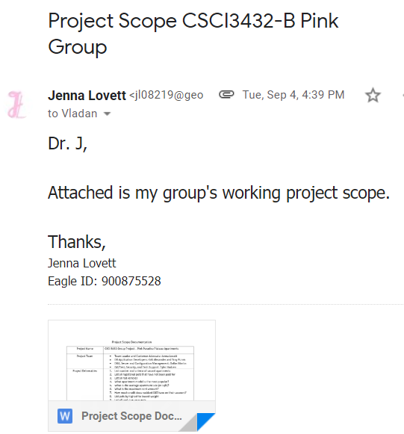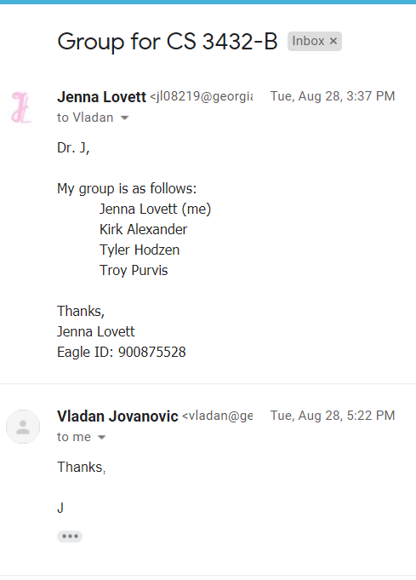

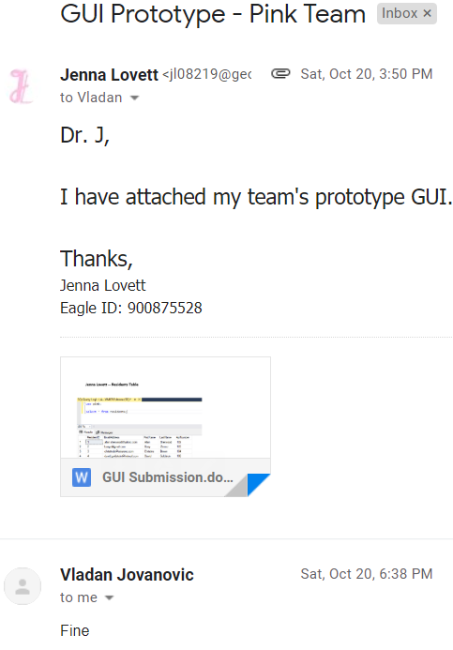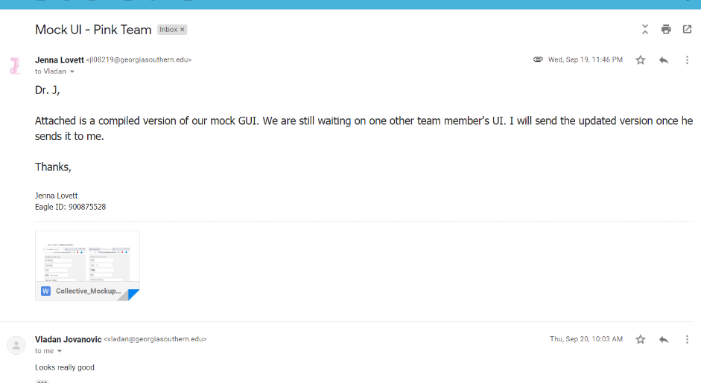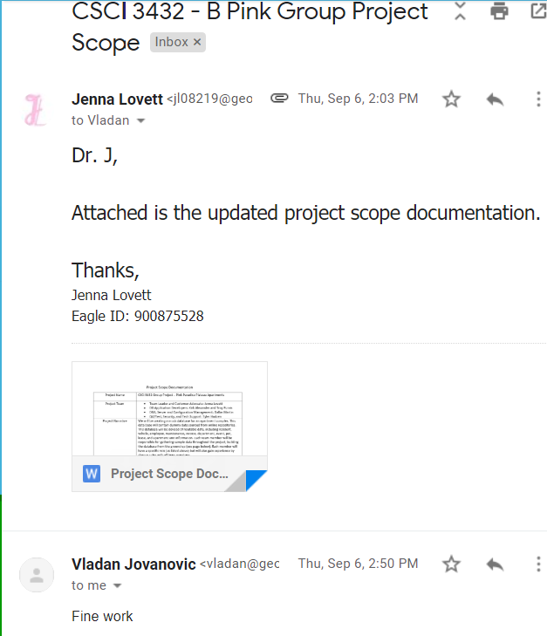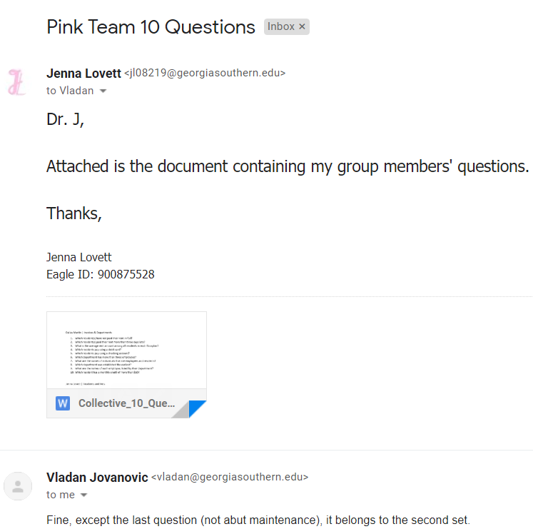

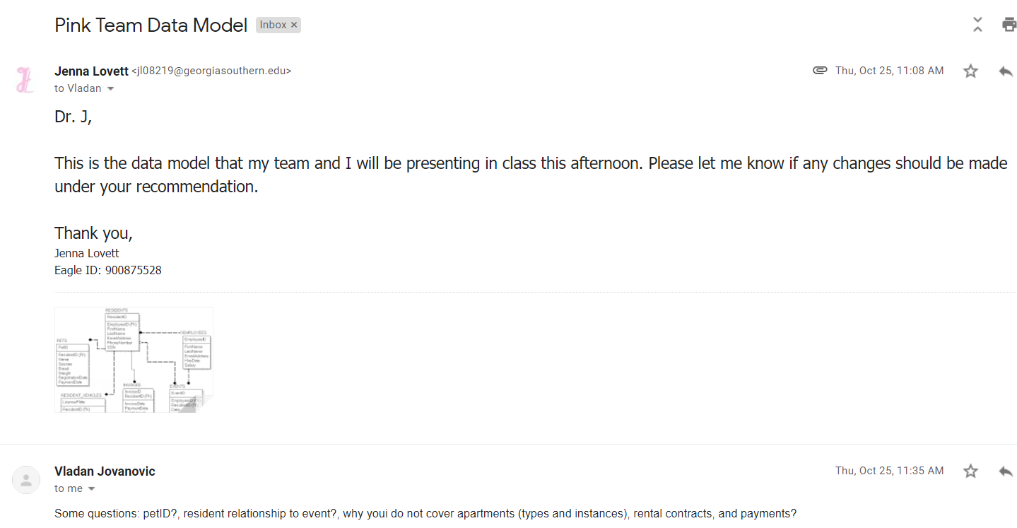

**Pink Database Script and Views (Tyler Hodzen, Troy Purvis, Jenna Lovett)**

USE master;

GO

IF DB_ID('Pink') IS NOT NULL

DROP DATABASE Pink;

GO

CREATE DATABASE Pink;

GO

USE Pink;

-- create the tables for the database

CREATE TABLE Employees (

EmployeeID INT PRIMARY KEY IDENTITY,

EmailAddress VARCHAR(255) NOT NULL,

JobTitle CHAR(20) NOT NULL,

FirstName VARCHAR(255) NOT NULL,

LastName VARCHAR(255) NOT NULL,

HireDate DATETIME NOT NULL,

Salary DECIMAL(9,2) NOT NULL

);

CREATE TABLE Residents(

ResidentID INT PRIMARY KEY IDENTITY,

EmployeeID INT FOREIGN KEY REFERENCES Employees(EmployeeID) DEFAULT NULL,

EmailAddress VARCHAR(255) NOT NULL UNIQUE,

FirstName VARCHAR(60) NOT NULL,

LastName VARCHAR(60) NOT NULL,

PhoneNumber VARCHAR(20) NOT NULL

);

CREATE TABLE Payments (

PaymentID INT IDENTITY,

ResidentID INT NOT NULL,

PaymentDate DATETIME NOT NULL,

RentAmount MONEY NOT NULL,

CreditAmount MONEY NOT NULL,

DueDate DATETIME DEFAULT NULL,

CardType VARCHAR(50) NOT NULL,

CardNumber CHAR(24) NOT NULL,

constraint PK_Payments primary key (PaymentID, ResidentID),

constraint FK_Payments foreign key (ResidentID) references Residents(ResidentID)

);

CREATE TABLE Pets (

ResidentID int NOT NULL,

Species varchar(60),

Breed varchar(60),

RegistrationDate DateTime,

PaymentDate DateTime,

constraint PK_PETS primary key (ResidentID),

constraint FK_PETS_ResidentID foreign key (ResidentID) references Residents(ResidentID)

);

CREATE TABLE ResidentVehicles (

LicensePlate varchar(60) NOT NULL,

ResidentID int NOT NULL,

Make varchar(20),

Model varchar(20),

Color varchar(20),

RegistrationDate DateTime,

DecalSticker varchar(20),

constraint PK_RESIDENT_VEHICLES primary key (LicensePlate),

constraint FK_RESIDENT_VEHICLES foreign key (ResidentID) REFERENCES Residents(ResidentID)

);

CREATE TABLE EventsLog (

EventID INT Not Null IDENTITY,

EmployeeID INT Foreign key References Employees (EmployeeID) Not Null,

ResidentID INT Foreign Key References Residents (ResidentID) Not Null,

EDate DateTime Not Null,

ELocation VARCHAR(50) Not Null,

EDesc VARCHAR(50) Not Null

constraint PK_Events primary key (EventID)

);

CREATE TABLE Apartments (

ApartmentNum INT NOT NULL PRIMARY KEY IDENTITY,

NumBeds INT NOT NULL,

NumBaths INT NOT NULL,

Sqft INT NOT NULL

);

CREATE TABLE Contracts (

ContractID INT NOT NULL IDENTITY,

ResidentID INT FOREIGN KEY REFERENCES Residents(ResidentID) NOT NULL,

ApartmentNum INT FOREIGN KEY REFERENCES Apartments(ApartmentNum) NOT NULL,

Price MONEY NOT NULL,

StartDate DATE NOT NULL,

EndDate DATE NOT NULL,

PetsAllowed BIT NOT NULL,

SmokingAllowed BIT NOT NULL,

Specials VARCHAR(60) DEFAULT NULL,

constraint PK_Contracts primary key (ContractID, ResidentID, ApartmentNum)

);

-- Insert data into the tables

SET IDENTITY_INSERT Apartments ON;

INSERT INTO Apartments(ApartmentNum, NumBeds, NumBaths, Sqft) VALUES

(100, 4, 4, 1000),

(101, 4, 4, 1000),

(102, 4, 4, 1000),

(103, 4, 4, 1000),

(104, 4, 4, 1000),

(105, 4, 4, 1000),

(106, 4, 4, 1000),

(107, 4, 4, 1000),

(108, 4, 4, 1000),

(109, 4, 4, 1000),

(110, 4, 4, 1000),

(111, 3, 4, 1000),

(112, 3, 4, 1000),

(113, 3, 4, 1000),

(114, 3, 4, 1000),

(115, 3, 4, 1000),

(116, 2, 4, 1000),

(117, 2, 4, 1000),

(118, 2, 4, 1000),

(119, 2, 4, 1000),

(120, 2, 4, 1000),

(121, 2, 4, 1000),

(122, 2, 4, 1000),

(123, 3, 4, 1000),

(124, 3, 4, 1000),

(125, 3, 4, 1000),

(126, 3, 4, 1000),

(127, 3, 4, 1000),

(128, 3, 4, 1000),

(129, 4, 4, 1000),

(130, 4, 4, 1200),

(131, 3, 4, 1200),

(132, 2, 4, 1300),

(133, 2, 4, 1300),

(134, 2, 4, 1300),

(135, 2, 4, 1300),

(136, 2, 4, 1300),

(137, 2, 4, 1300),

(138, 2, 4, 1300),

(139, 3, 4, 1300),

(140, 3, 4, 1400),

(141, 3, 4, 1400),

(142, 3, 4, 1400),

(143, 3, 4, 1400),

(144, 3, 4, 1000),

(145, 4, 4, 1000),

(146, 4, 4, 1000),

(147, 3, 4, 1000),

(148, 3, 4, 1000),

(149, 4, 4, 1000),

(150, 4, 4, 1000);

SET IDENTITY_INSERT Apartments OFF;

SET IDENTITY_INSERT Employees ON;

INSERT INTO Employees(EmployeeID, EmailAddress, JobTitle, FirstName, LastName, HireDate, Salary) VALUES

(1, 'joe@pinkapartments.com', 'Groundsman', 'Joe', 'Davis', '2016-05-07 03:53:06.000', '50000.00'),

(2, 'mark@pinkapartments.com', 'Groundsman', 'Mark', 'Davis', '2016-05-07 03:53:06.000', '25000.00'),

(3, 'jerry@pinkapartments.com', 'Leaser', 'Jerry', 'Davis', '2016-05-07 03:53:06.000', '30000.00'),

(4, 'julie@pinkapartments.com', 'Leaser', 'Julie', 'Davis', '2016-05-07 03:53:06.000', '30000.00'),

(5, 'amy@pinkapartments', 'Leaser', 'Amy', 'Davis', '2016-05-07 03:53:06.000', '30000.00'),

(6, 'veronica@pinkapartments.com', 'Property Manager', 'Veronica', 'Davis', '2016-05-07 03:53:06.000', '30000.00'),

(7, 'david@pinkapartments.com', 'Security', 'David', 'Davis', '2016-05-07 03:53:06.000', '30000.00'),

(8, 'mary@pinkapartments.com', 'Security', 'Mary', 'Davis', '2016-05-07 03:53:06.000', '30000.00'),

(9, 'andy@pinkapartments.com', 'Electrician', 'Andy', 'Davis', '2016-05-07 03:53:06.000', '35000.00'),

(10, 'mali@myguitarshop.com', 'Groundsman', 'Mali', 'Carson', '2016-05-07 03:53:06.000', '45000.00'),

(11, 'madalyn@myguitarshop.com', 'Electrician', 'Madalyn', 'Dudley', '2016-05-07 03:53:06.000', '60000.00'),

(12, 'rex@myguitarshop.com', 'Leaser', 'Rex', 'Mayo', '2016-05-07 03:53:06.000', '30000.00'),

(13, 'darion@myguitarshop.com', 'Administrator', 'Darion', 'Powel', '2016-05-07 03:53:06.000', '30000.00'),

(14, 'ellen@myguitarshop.com', 'Administrator', 'Ellen', 'Garrison', '2016-05-07 03:53:06.000', '90000.00'),

(15, 'daya@myguitarshop.com', 'IT Technician', 'Daya', 'Roads', '2016-05-07 03:53:06.000', '90000.00'),

(16, 'brent@myguitarshop.com', 'Groundsman', 'Brent', 'Fenton', '2016-05-07 03:53:06.000', '30000.00'),

(17, 'rhode@myguitarshop.com', 'Groundsman', 'Rhode', 'Davis', '2016-05-07 03:53:06.000', '30000.00'),

(18, 'lucero@myguitarshop.com', 'Security', 'Lucero', 'Davis', '2016-05-07 03:53:06.000', '30000.00'),

(19, 'joanna@myguitarshop.com', 'Groundsman', 'Joanna', 'Jackson', '2016-05-07 03:53:06.000', '40000.00'),

(20, 'alice@myguitarshop.com', 'Leaser', 'Alice', 'Tapley', '2016-05-07 03:53:06.000', '40000.00');

SET IDENTITY_INSERT Employees OFF;

SET IDENTITY_INSERT Residents ON;

INSERT INTO Residents(ResidentID, EmployeeID, EmailAddress, FirstName, LastName, PhoneNumber) VALUES

(1, 1, 'joe@pinkapartments.com', 'Joe', 'Davis', '555-555-5551'),

(2, NULL, 'barryz@gmail.com', 'Barry', 'Zimmer', '555-555-5552'),

(3, NULL, 'christineb@solarone.com', 'Christine', 'Brown', '555-555-5553'),

(4, NULL, 'david.goldstein@hotmail.com', 'David', 'Goldstein', '555-555-5554'),

(5, 2, 'mark@pinkapartments.com', 'Mark', 'Davis', '555-555-5555'),

(6, NULL, 'frankwilson@sbcglobal.net', 'Frank Lee', 'Wilson', '555-555-5556'),

(7, NULL, 'gary_hernandez@yahoo.com', 'Gary', 'Hernandez', '555-555-5557'),

(8, NULL, 'heatheresway@mac.com', 'Heather', 'Esway', '555-555-5558'),

(9, 3, 'jerry@pinkapartments.com', 'Jerry', 'Davis', '555-555-5559'),

(10, 4, 'julie@pinkapartments.com', 'Julie', 'Davis', '555-555-5510'),

(11, NULL, 'cash.black@yahoo.com', 'Cash', 'Black', '555-111-5551'),

(12, NULL, 'karina.ter@gmail.com', 'Karina', 'Terrell', '555-111-5552'),

(13, NULL, 'jordin.parks@solarone.com', 'Jordin', 'Parks', '555-111-5553'),

(14, NULL, 'kaylin.shea@hotmail.com', 'Kaylin', 'Shea', '555-111-5554'),

(15, NULL, 'naima@gmail.com', 'Naima', 'Carlson', '555-111-5555'),

(16, NULL, 'Skye.was@sbcglobal.net', 'Skye', 'Was', '555-111-5556'),

(17, NULL, 'Rowan.camp@yahoo.com', 'Rowan', 'Campos', '555-111-5557'),

(18, NULL, 'Davon.Right@mac.com', 'Davon', 'Right', '555-111-5558'),

(19, NULL, 'scarlett.hoop@gmail.com', 'Scarlett', 'Hooper', '555-111-5559'),

(20, NULL, 'Jasmine.chapm@darakjy.org', 'Jasmine', 'Chapman', '555-111-5510'),

(21, NULL, 'kaylen@yahoo.com', 'Kaylen', 'Gibbs', '555-222-5551'),

(22, NULL, 'yoselin.ter@gmail.com', 'Yoselin', 'Terrell', '555-222-5552'),

(23, NULL, 'jack.parks@solarone.com', 'Jack', 'Parks', '555-222-5553'),

(24, NULL, 'Messiah.shea@hotmail.com', 'Messiah', 'Shea', '555-222-5554'),

(25, NULL, 'adeoan@gmail.com', 'Adeoan', 'Carlson', '555-222-5555'),

(26, NULL, 'makaila@sbcglobal.net', 'Makaila', 'Was', '555-222-5556'),

(27, NULL, 'alondra.camp@yahoo.com', 'Alondra', 'Campos', '555-222-5557'),

(28, NULL, 'itskane@mac.com', 'Kane', 'Right', '555-222-5558'),

(29, NULL, 'ignacio@gmail.com', 'Ignacio', 'Hooper', '555-222-5559'),

(30, NULL, 'Aubrey.Henz@darakjy.org', 'Aubrey', 'Henz', '555-222-5510'),

(31, NULL, 'frances.waller@yahoo.com', 'Frances', 'Waller', '555-333-5551'),

(32, NULL, 'cara.yu@gmail.com', 'Cara', 'Yu', '555-333-5552'),

(33, NULL, 'colby.gray@solarone.com', 'Colby', 'Gray', '555-333-5553'),

(34, NULL, 'Hailie.Nichols@hotmail.com', 'Hailie', 'Nichols', '555-333-5554'),

(35, NULL, 'leia.barr@gmail.com', 'Leia', 'Barr', '555-333-5555'),

(36, NULL, 'brycen@sbcglobal.net', 'Brycen', 'Briggs', '555-333-5556'),

(37, NULL, 'lill.fly@yahoo.com', 'Lilly', 'Flynn', '555-333-5557'),

(38, NULL, 'nilo.byid@mac.com', 'Nilo', 'Byid', '555-333-5558'),

(39, NULL, 'Nelson@gmail.com', 'Nelson', 'Bauer', '555-333-5559'),

(40, NULL, 'Grayson.pena@darakjy.org', 'Grayson', 'Pena', '555-333-5510'),

(41, NULL, 'levi.waller@yahoo.com', 'Levi', 'Waller', '555-444-5551'),

(42, NULL, 'mathias.miles@gmail.com', 'Miles', 'Mathias', '555-444-5552'),

(43, NULL, 'myleswalls@solarone.com', 'Myles', 'Walls', '555-444-5553'),

(44, NULL, 'Breena.lut@hotmail.com', 'Breena', 'Lut', '555-444-5554'),

(45, NULL, 'rachel.han@gmail.com', 'Rachel', 'Han', '555-444-5555'),

(46, NULL, 'Cadon.meadows@sbcglobal.net', 'Cadon', 'Meadows', '555-444-5556'),

(47, NULL, 'kameron.nu@yahoo.com', 'Cameron', 'Nu', '555-444-5557'),

(48, NULL, 'arely.morgon@mac.com', 'Arely', 'Morgon', '555-444-5558'),

(49, NULL, 'tamara.eidn@gmail.com', 'Tamara', 'Eid', '555-444-5559'),

(50, NULL, 'Greyna@darakjy.org', 'Grayy', 'Na', '555-444-5510');

SET IDENTITY_INSERT Residents OFF;

SET IDENTITY_INSERT Contracts ON;

INSERT INTO Contracts(ContractID, ResidentID, ApartmentNum, Price, StartDate, EndDate, PetsAllowed, SmokingAllowed, Specials) VALUES

(1, 1, 100, 1000.00, '2015-9-5', '2016-9-5', 1, 1, 'Free Xbox'),

(2, 2, 101, 1000.00, '2015-9-5', '2016-9-5', 1, 1, 'Free Xbox'),

(3, 3, 102, 1000.00, '2015-9-5', '2016-9-5', 1, 1, 'Free Xbox'),

(4, 4, 103, 1000.00, '2015-9-5', '2016-9-5', 1, 1, 'Free Xbox'),

(5, 5, 104, 1000.00, '2015-9-5', '2016-9-5', 1, 1, 'Free Xbox'),

(6, 6, 105, 1000.00, '2015-9-5', '2016-9-5', 1, 1, 'Free Xbox'),

(7, 7, 106, 1000.00, '2015-9-5', '2016-9-5', 1, 1, 'Free Xbox'),

(8, 8, 107, 1000.00, '2015-9-5', '2016-9-5', 1, 1, 'Free Xbox'),

(9, 9, 108, 1000.00, '2015-9-5', '2016-9-5', 1, 1, 'Free Xbox'),

(10, 10, 109, 1100.00, '2018-9-5', '2019-9-5', 1, 1, '1mo rent free'),

(11, 11, 110, 1100.00, '2018-9-5', '2019-9-5', 1, 1, 'free speaker'),

(12, 12, 111, 1050.00, '2018-9-5', '2019-9-5', 1, 1, '1mo rent free'),

(13, 13, 112, 1050.00, '2018-9-5', '2019-9-5', 1, 1, 'free speaker'),

(14, 14, 113, 1020.00, '2018-9-5', '2019-9-5', 1, 1, '1mo rent free'),

(15, 15, 114, 1500.00, '2018-9-5', '2019-9-5', 1, 1, '1mo rent free'),

(16, 16, 115, 1400.00, '2018-9-5', '2019-9-5', 1, 1, 'free speaker'),

(17, 17, 116, 1200.00, '2018-9-5', '2019-9-5', 1, 1, '1mo rent free'),

(18, 18, 117, 1000.00, '2018-9-5', '2019-9-5', 1, 1, '1mo rent free'),

(19, 19, 118, 1200.00, '2018-9-5', '2019-9-5', 1, 1, '1mo rent free'),

(20, 20, 119, 1300.00, '2018-9-5', '2019-9-5', 1, 1, '1mo rent free'),

(21, 21, 120, 1100.00, '2018-9-5', '2019-9-5', 0, 1, 'free speaker'),

(22, 22, 121, 1050.00, '2018-9-5', '2019-9-5', 1, 1, '1mo rent free'),

(23, 23, 122, 1050.00, '2018-9-5', '2019-9-5', 1, 0, '1mo rent free'),

(24, 24, 123, 1020.00, '2018-9-5', '2019-9-5', 1, 1, '1mo rent free'),

(25, 25, 124, 1500.00, '2018-9-5', '2019-9-5', 1, 1, '1mo rent free'),

(26, 26, 125, 1400.00, '2018-9-5', '2019-9-5', 1, 0, 'free speaker'),

(27, 27, 126, 1200.00, '2018-9-5', '2019-9-5', 1, 0, '1mo rent free'),

(28, 28, 127, 1000.00, '2018-9-5', '2019-9-5', 0, 1, '1mo rent free'),

(29, 29, 128, 1200.00, '2018-9-5', '2019-9-5', 1, 1, 'free speaker'),

(30, 30, 129, 1300.00, '2018-9-5', '2019-9-5', 1, 1, '1mo rent free'),

(31, 31, 130, 1100.00, '2018-9-5', '2019-9-5', 0, 1, '1mo rent free'),

(32, 32, 131, 1050.00, '2018-9-5', '2019-9-5', 1, 1, '1mo rent free'),

(33, 33, 132, 1050.00, '2018-9-5', '2019-9-5', 1, 0, 'free speaker'),

(34, 34, 133, 1020.00, '2018-9-5', '2019-9-5', 1, 1, '1mo rent free'),

(35, 35, 134, 1500.00, '2018-9-5', '2019-9-5', 1, 1, '1mo rent free'),

(36, 36, 135, 1400.00, '2018-9-5', '2019-9-5', 1, 0, '1mo rent free'),

(37, 37, 136, 1200.00, '2018-9-5', '2019-9-5', 1, 0, '1mo rent free'),

(38, 38, 137, 1000.00, '2018-9-5', '2019-9-5', 0, 1, '1mo rent free'),

(39, 39, 138, 1200.00, '2018-9-5', '2019-9-5', 1, 1, 'free phone'),

(40, 40, 139, 1300.00, '2018-9-5', '2019-9-5', 1, 1, '1mo rent free');

SET IDENTITY_INSERT Contracts OFF;

SET IDENTITY_INSERT EventsLog ON;

INSERT INTO EventsLog(EventID, EmployeeID, ResidentID, EDate, ELocation, EDesc) VALUES

(1, 1, 1, '2015-9-5', 'Theater', 'Watched a movie'),

(2, 1, 1, '2015-10-5', 'Pool', 'Swimming Match'),

(3, 1, 1, '2015-9-8', 'Pool', 'Swimming Match'),

(4, 1, 1, '2015-9-12', 'Grill', 'BBQ'),

(5, 1, 1, '2015-10-31', 'Pool', 'Swimming Match'),

(6, 1, 1, '2016-9-10', 'Theater', 'Watched a movie'),

(7, 1, 1, '2015-12-5', 'Lounge', 'Watched a movie'),

(8, 1, 1, '2015-11-15', 'Bar', 'Drank'),

(9, 1, 1, '2015-9-15', 'Tennis Courts', 'Played tennis'),

(10, 1, 1, '2018-12-15', 'Bar', 'Drank'),

(11, 1, 1, '2018-12-15', 'Pool', 'Swimming Match'),

(12, 1, 3, '2018-12-05', 'Pool', 'Swimming Match'),

(13, 1, 1, '2018-12-25', 'Pool', 'Swimming Match'),

(14, 1, 2, '2018-12-15', 'Grill', 'BBQ'),

(15, 1, 1, '2018-12-03', 'Pool', 'Swimming Match'),

(16, 1, 1, '2018-12-18', 'Theater', 'Watched a movie'),

(17, 1, 2, '2018-12-5', 'Lounge', 'Watched a movie'),

(18, 1, 2, '2018-11-15', 'Bar', 'Drank'),

(19, 1, 2, '2018-9-15', 'Tennis Courts', 'Played tennis'),

(20, 1, 1, '2018-9-15', 'Bar', 'Drank'),

(21, 1, 1, '2018-12-15', 'Pool', 'Swimming Match'),

(22, 1, 3, '2018-12-15', 'Pool', 'Swimming Match'),

(23, 1, 1, '2018-09-15', 'Pool', 'Swimming Match'),

(24, 1, 2, '2018-12-15', 'Grill', 'BBQ'),

(25, 1, 1, '2018-10-15', 'Pool', 'Swimming Match');

SET IDENTITY_INSERT EventsLog OFF;

INSERT INTO Pets (ResidentID, Species, Breed, RegistrationDate, PaymentDate)

VALUES (1, 'Dog', 'German Shepherd', '2016-5-5', '2016-5-10'),

(2, 'Cat', 'Calico', '2015-8-1', '2015-9-5'),

(3, 'Dog', 'Tibby', '2016-1-5', '2016-1-30'),

(4, 'Cat', 'Alley', '2017-3-3', '2017-4-20'),

(5, 'Dog', 'Pug', '2016-10-10', '2016-11-12'),

(10, 'Dog', 'German Shepherd', '2018-12-5', '2018-12-5'),

(11, 'Cat', 'Calico', '2018-12-5', '2018-12-5'),

(12, 'Dog', 'Tibby', '2018-12-5', '2018-12-5'),

(20, 'Cat', 'Alley', '2018-12-5', '2018-12-5'),

(21, 'Dog', 'Pug', '2018-12-5', '2018-12-5'),

(22, 'Dog', 'German Shepherd', '2018-12-5', '2018-12-5'),

(23, 'Cat', 'Calico', '2018-12-5', '2018-12-5'),

(24, 'Dog', 'Tibby', '2018-12-5', '2018-12-5'),

(25, 'Cat', 'Alley', '2018-12-5', '2018-12-5'),

(26, 'Dog', 'Lab', '2018-12-5', '2018-12-5'),

(27, 'Dog', 'German Shepherd', '2018-12-5', '2018-12-5'),

(28, 'Cat', 'Calico', '2018-12-5', '2018-12-5'),

(30, 'Dog', 'Lab', '2018-12-5', '2018-12-5');

INSERT INTO ResidentVehicles (LicensePlate, ResidentID, Make, Model, Color, RegistrationDate, DecalSticker)

VALUES

( 'abc-123', 1, 'Honda', 'Civic', 'Black', '2016-5-5', 'a0sijf'),

( 'zbd-14d', 2, 'Ford', 'F-150', 'Grey', '2015-1-30', 'asoihf'),

( 'bdb-322', 3, 'Tesla', 'Model 3', 'Red', '2018-5-3', 'memes'),

( 'asd-fgh', 4, 'Nissan', 'GTR', 'Black', '2013-9-4', 'zxcvgr'),

( 'jk55g', 5, 'Volkswagen', 'Beatle', 'Blue', '2018-2-3', 'qwertyu'),

( 'hjjkhj', 6, 'Honda', 'Civic', 'Black', '2016-5-5', 'a5555f'),

( 'z879yg', 7, 'Ford', 'F-150', 'Grey', '2015-1-30', 'a5752'),

( 'sfge46', 8, 'Tesla', 'Model 3', 'Red', '2018-5-3', 'm5888es'),

( '56urfjf', 10, 'Nissan', 'GTR', 'Black', '2013-9-4', 'z68885'),

( 'jfgfdgss', 11, 'Volkswagen', 'Beatle', 'Blue', '2018-12-3', 'qiyui'),

( 'ffgt3', 12, 'Honda', 'Civic', 'Black', '2018-12-3', 'a0y8888'),

( 'fghrwqa', 12, 'Ford', 'F-150', 'Grey', '2018-12-3', 'asr4ess'),

( 'bhytrrr', 13, 'Tesla', 'Model 3', 'Red', '2018-12-3', 'jyyr'),

( '657rff', 14, 'Nissan', 'GTR', 'Black', '2018-12-3', 'z54445'),

( 'jhfhee', 15, 'Volkswagen', 'Beatle', 'Blue', '2018-12-3', 'q00008'),

( 'dfgrr', 16, 'Honda', 'Civic', 'Black', '2018-12-3', 'tysssd5'),

( 'zbdfghd', 17, 'Ford', 'F-150', 'Grey', '2018-10-3', 'u7778'),

( 'bmhhggg2', 18, 'Tesla', 'Model 3', 'Red', '2018-10-3', 'iu888'),

( 'ghjjjb', 20, 'Nissan', 'GTR', 'Black', '2018-12-3', 'z74eer'),

( 'j7766ghn', 20, 'Volkswagen', 'Beatle', 'Blue', '2018-12-3', 'qwiioo'),

( 'anfd3', 20, 'Honda', 'Civic', 'Black', '2018-12-3', 'a0008f'),

( 'kgjddd', 22, 'Ford', 'F-150', 'Grey', '2018-12-3', 'a77776'),

( 'dt522', 23, 'Tesla', 'Model 3', 'Red', '2018-12-3', 'memof6'),

( 'ashgjhj', 34, 'Nissan', 'GTR', 'Black', '2018-12-3', 'z434ff'),

( 'jkghjjj', 35, 'Volkswagen', 'Beatle', 'Blue', '2018-12-3', 'cffgb');

SET IDENTITY_INSERT Payments ON;

INSERT INTO Payments(PaymentID, ResidentID, PaymentDate, RentAmount, CreditAmount, DueDate, CardType, CardNumber) VALUES

(1, 10, '2018-10-28 09:40:28.000', 1000.00, 0.0, '2018-10-29 09:40:28.000', 'Visa', '4111111111111111'),

(2, 12, '2018-10-28 09:40:28.000', 1000.00, 0.0, '2018-10-29 09:40:28.000', 'American Express', '3782822463100005'),

(3, 13, '2018-10-28 09:40:28.000', 1000.00, 0.0, '2018-10-29 09:40:28.000', 'Discover', '6011111111111117'),

(4, 14, '2018-10-28 09:40:28.000', 1000.00, 0.0, '2018-10-29 09:40:28.000', 'MasterCard', '5555555555554444'),

(5, 15, '2018-10-28 09:40:28.000', 1000.00, 0.0, '2018-10-29 09:40:28.000', 'Visa', '101010101010'),

(6, 16, '2018-10-28 09:40:28.000', 1000.00, 0.0, '2018-10-29 09:40:28.000', 'MasterCard', '999999999999'),

(7, 17, '2018-10-28 09:40:28.000', 1000.00, 0.0, '2018-10-29 09:40:28.000', 'Visa', '98989898989898'),

(8, 18, '2018-10-28 09:40:28.000', 1000.00, 0.0, '2018-10-29 09:40:28.000', 'Visa', '411111111678111'),

(9, 19, '2018-10-28 09:40:28.000', 1000.00, 0.0, '2018-10-29 09:40:28.000', 'Visa', '41111111133331111'),

(10, 20, '2018-10-28 09:40:28.000', 1000.00, 0.0, '2018-10-29 09:40:28.000', 'Visa', '4111111111112211'),

(11, 21, '2018-10-28 09:40:28.000', 1000.00, 0.0, '2018-10-29 09:40:28.000', 'Visa', '411111189111111'),

(12, 22, '2018-10-28 09:40:28.000', 1000.00, 0.0, '2018-10-29 09:40:28.000', 'American Express', '3782822463100005'),

(13, 33, '2018-10-28 09:40:28.000', 1000.00, 0.0, '2018-10-29 09:40:28.000', 'Discover', '60111111117'),

(14, 34, '2018-10-28 09:40:28.000', 1000.00, 0.0, '2018-10-29 09:40:28.000', 'MasterCard', '5555554444'),

(15, 35, '2018-10-28 09:40:28.000', 1000.00, 0.0, '2018-10-29 09:40:28.000', 'Visa', '101010101010'),

(16, 36, '2018-10-28 09:40:28.000', 1000.00, 0.0, '2018-10-29 09:40:28.000', 'MasterCard', '8899999999999'),

(17, 37, '2018-10-28 09:40:28.000', 1000.00, 0.0, '2018-10-29 09:40:28.000', 'Visa', '9898989778888'),

(18, 38, '2018-10-28 09:40:28.000', 1000.00, 0.0, '2018-10-29 09:40:28.000', 'Visa', '4111111111177111'),

(19, 39, '2018-10-28 09:40:28.000', 1000.00, 0.0, '2018-10-29 09:40:28.000', 'Visa', '4111111871111111'),

(20, 23, '2018-10-28 09:40:28.000', 1000.00, 0.0, '2018-10-29 09:40:28.000', 'Visa', '4111188111111111');

SET IDENTITY_INSERT Payments OFF;

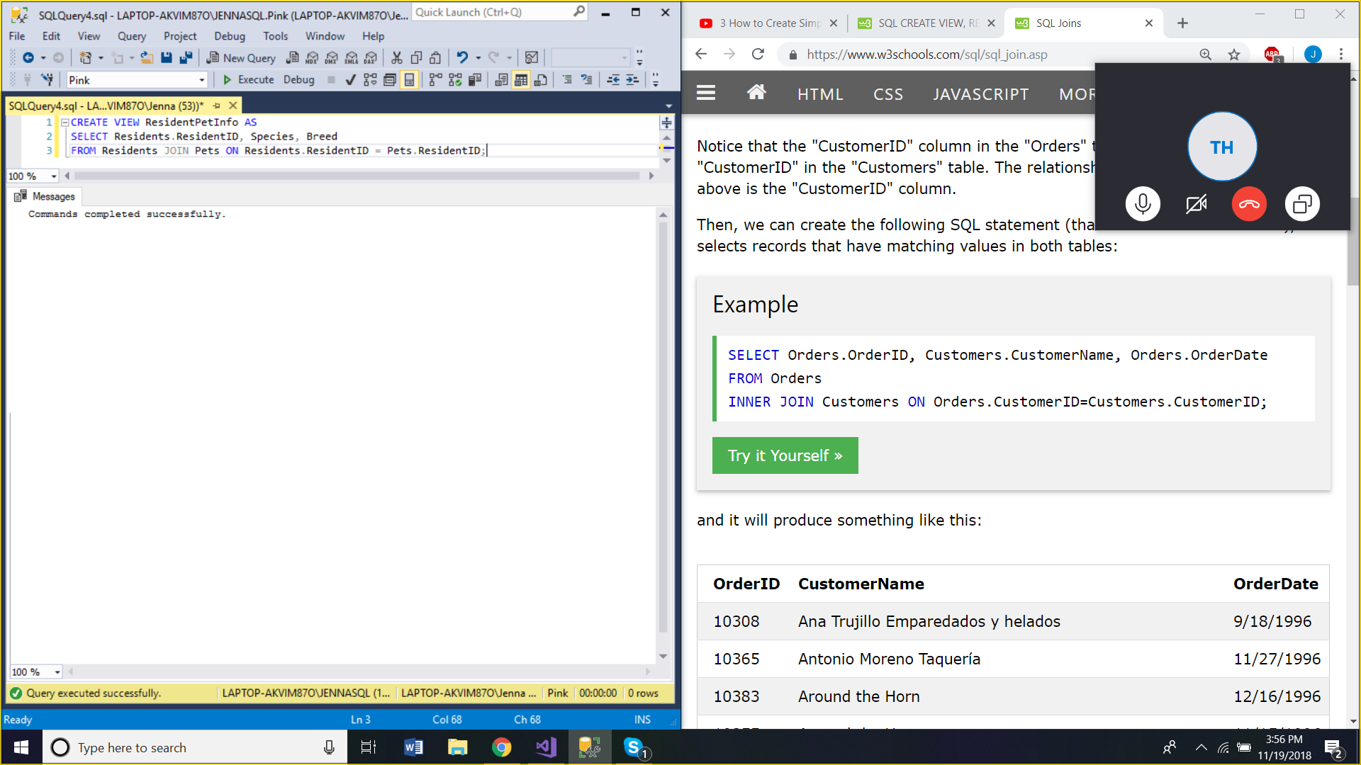

CREATE VIEW ResidentPetInfo AS

SELECT Residents.ResidentID, Species, Breed

FROM Residents JOIN Pets ON Residents.ResidentID = Pets.ResidentID;

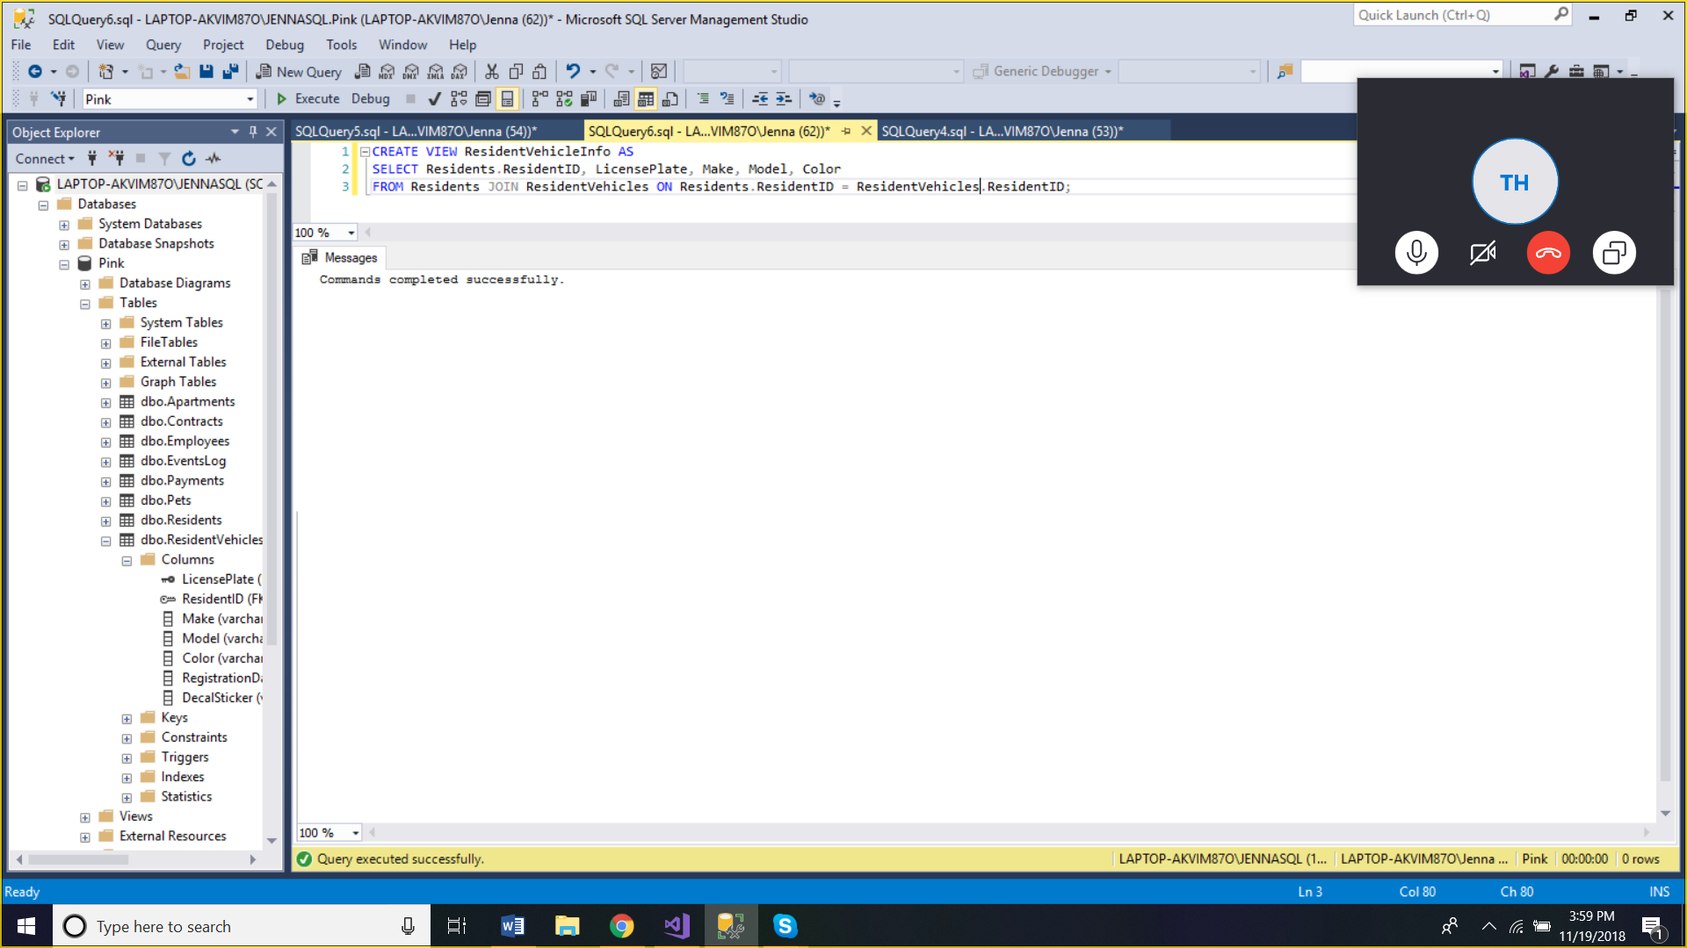

CREATE VIEW ResidentVehicleInfo AS

SELECT Residents.ResidentID, LicensePlate, Make, Model, Color

FROM Residents JOIN ResidentVehicles ON Residents.ResidentID = ResidentVehicles.ResidentID;

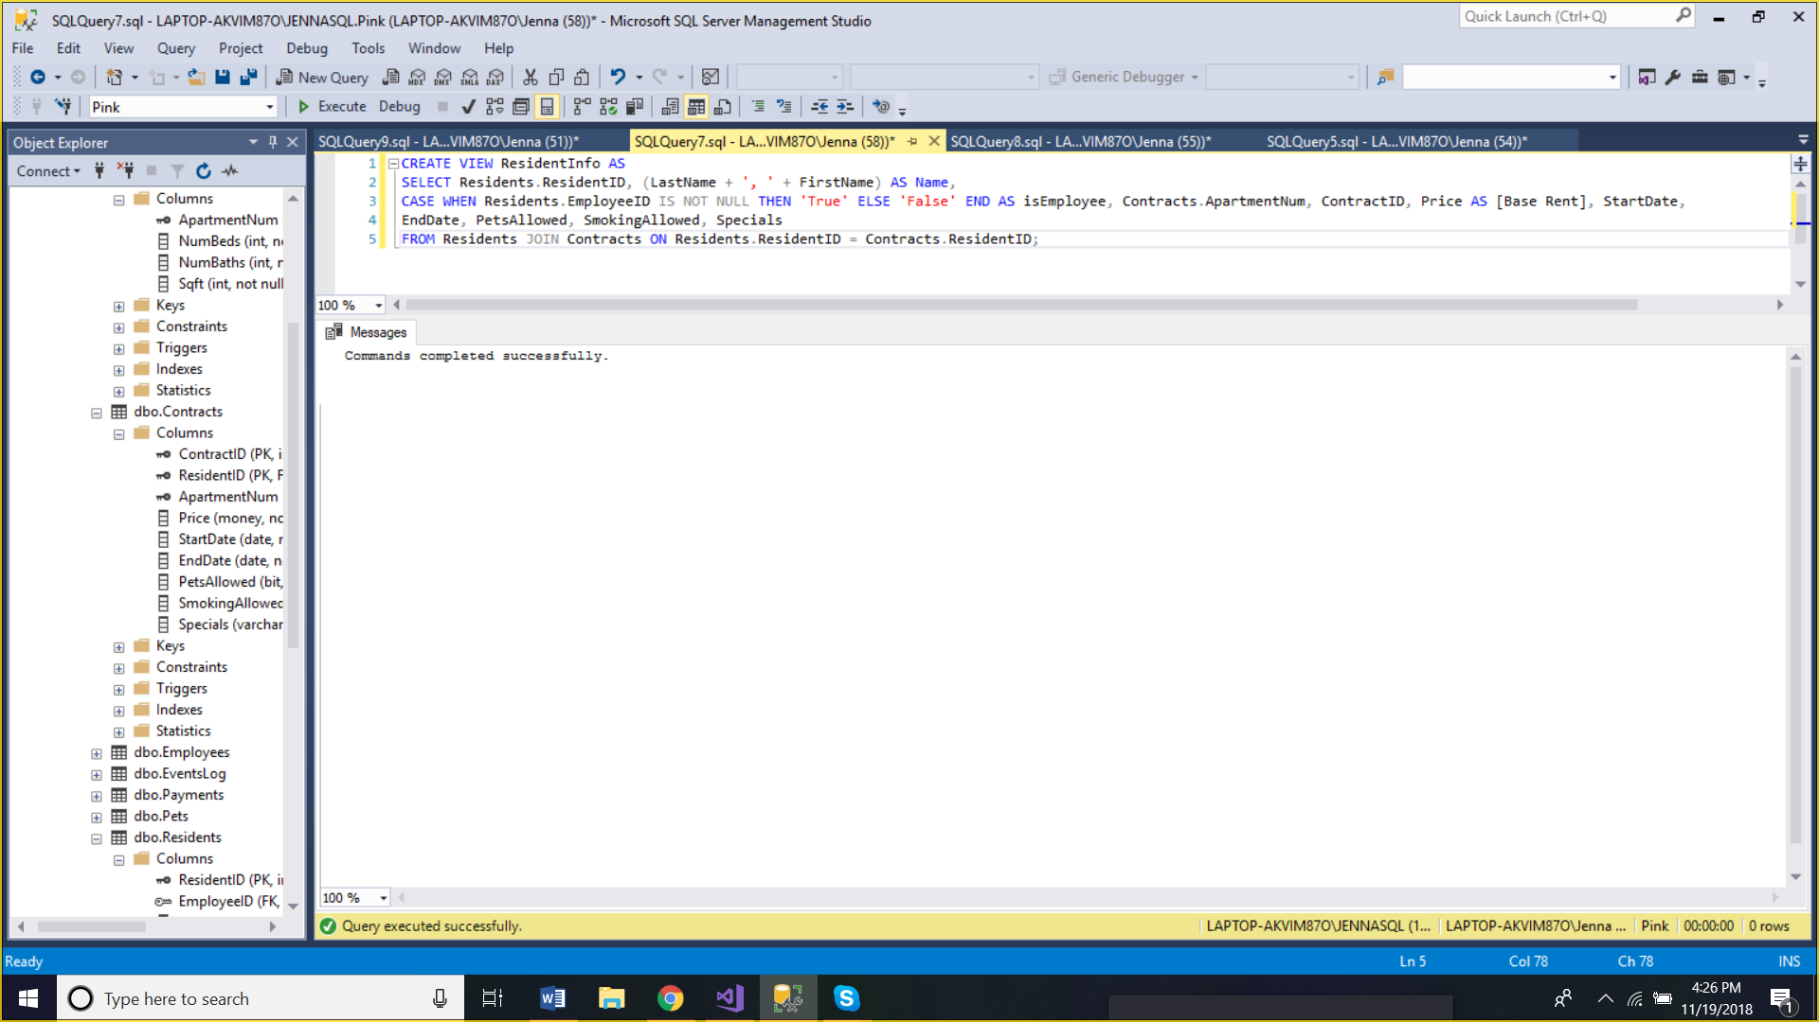

CREATE VIEW ResidentInfo AS

SELECT Residents.ResidentID, (LastName + ', ' + FirstName) AS Name,

CASE WHEN Residents.EmployeeID IS NOT NULL THEN 'True' ELSE 'False' END AS isEmployee,

Contracts.ApartmentNum, ContractID, Price AS [Base Rent], StartDate, EndDate, PetsAllowed, SmokingAllowed, Specials

FROM Residents JOIN Contracts ON Residents.ResidentID = Contracts.ResidentID;

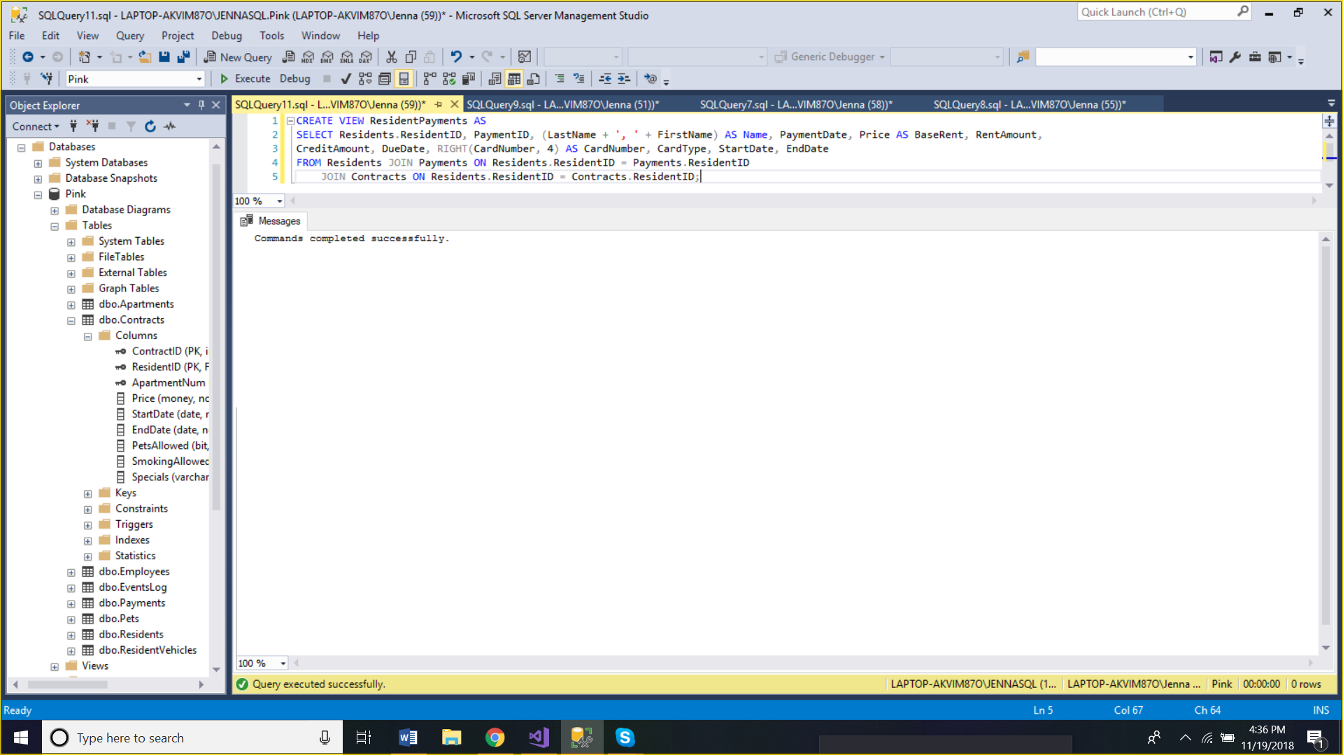

CREATE VIEW ResidentPayments AS

SELECT Residents.ResidentID, PaymentID, (LastName + ', ' + FirstName) AS Name, PaymentDate, Price AS [Base Rent], RentAmount,

DueDate, RIGHT(CardNumber, 4) AS CardNumber, CardType, StartDate, EndDate

FROM Residents JOIN Payments ON Residents.ResidentID = Payments.ResidentID

JOIN Contracts ON Residents.ResidentID = Contracts.ResidentID;

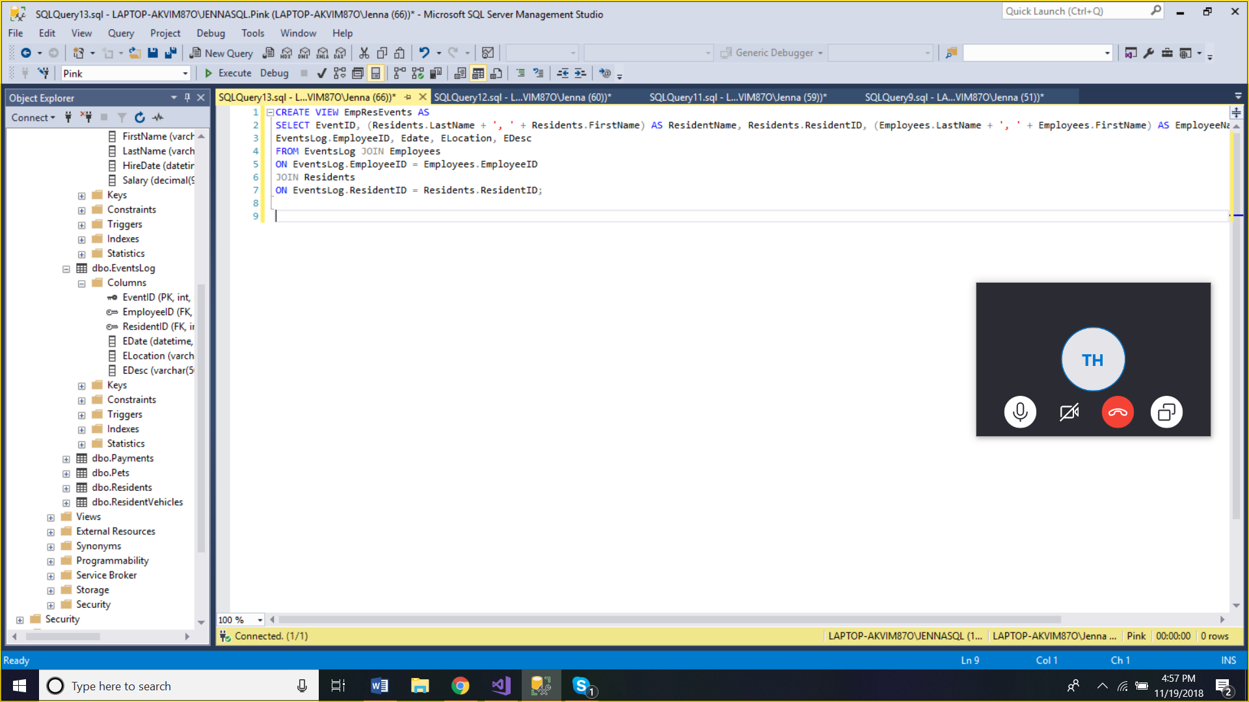

CREATE VIEW EmpResEvents AS

SELECT EventID, (Residents.LastName + ', ' + Residents.FirstName) AS Resident, Residents.ResidentID, (Employees.LastName + ', ' + Employees.FirstName) AS Employee,

EventsLog.EmployeeID, EDate, ELocation, EDesc

FROM EventsLog JOIN Employees ON EventsLog.EmployeeID = Employees.EmployeeID

JOIN Residents ON EventsLog.ResidentID = Residents.ResidentID;

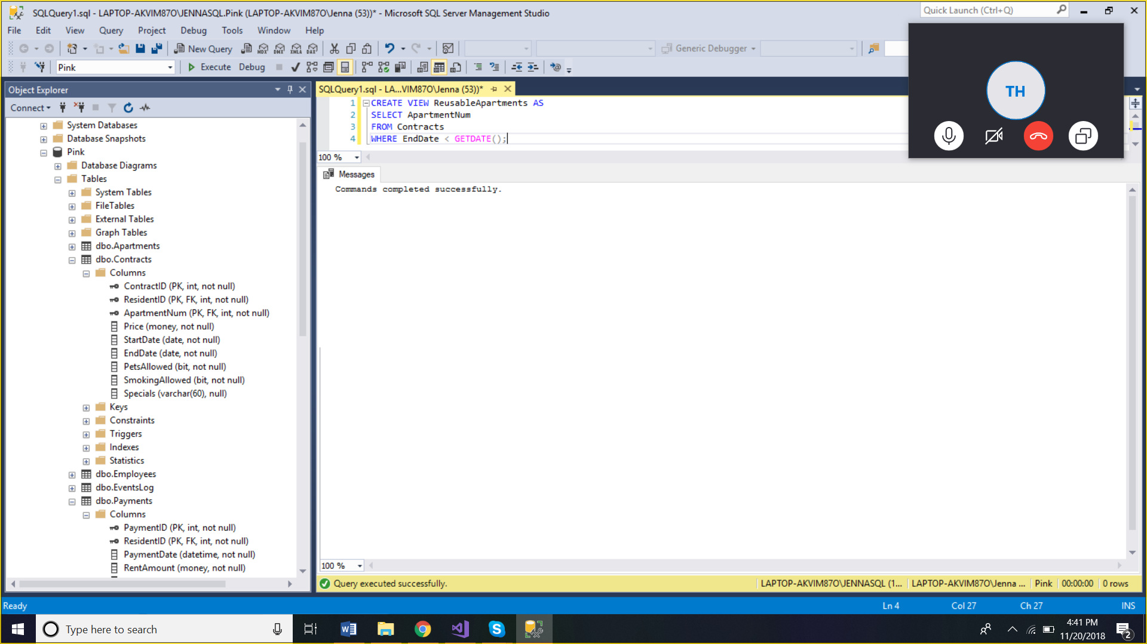

CREATE VIEW ReusableApartments AS

SELECT ApartmentNum

FROM Contracts

WHERE EndDate < GETDATE();

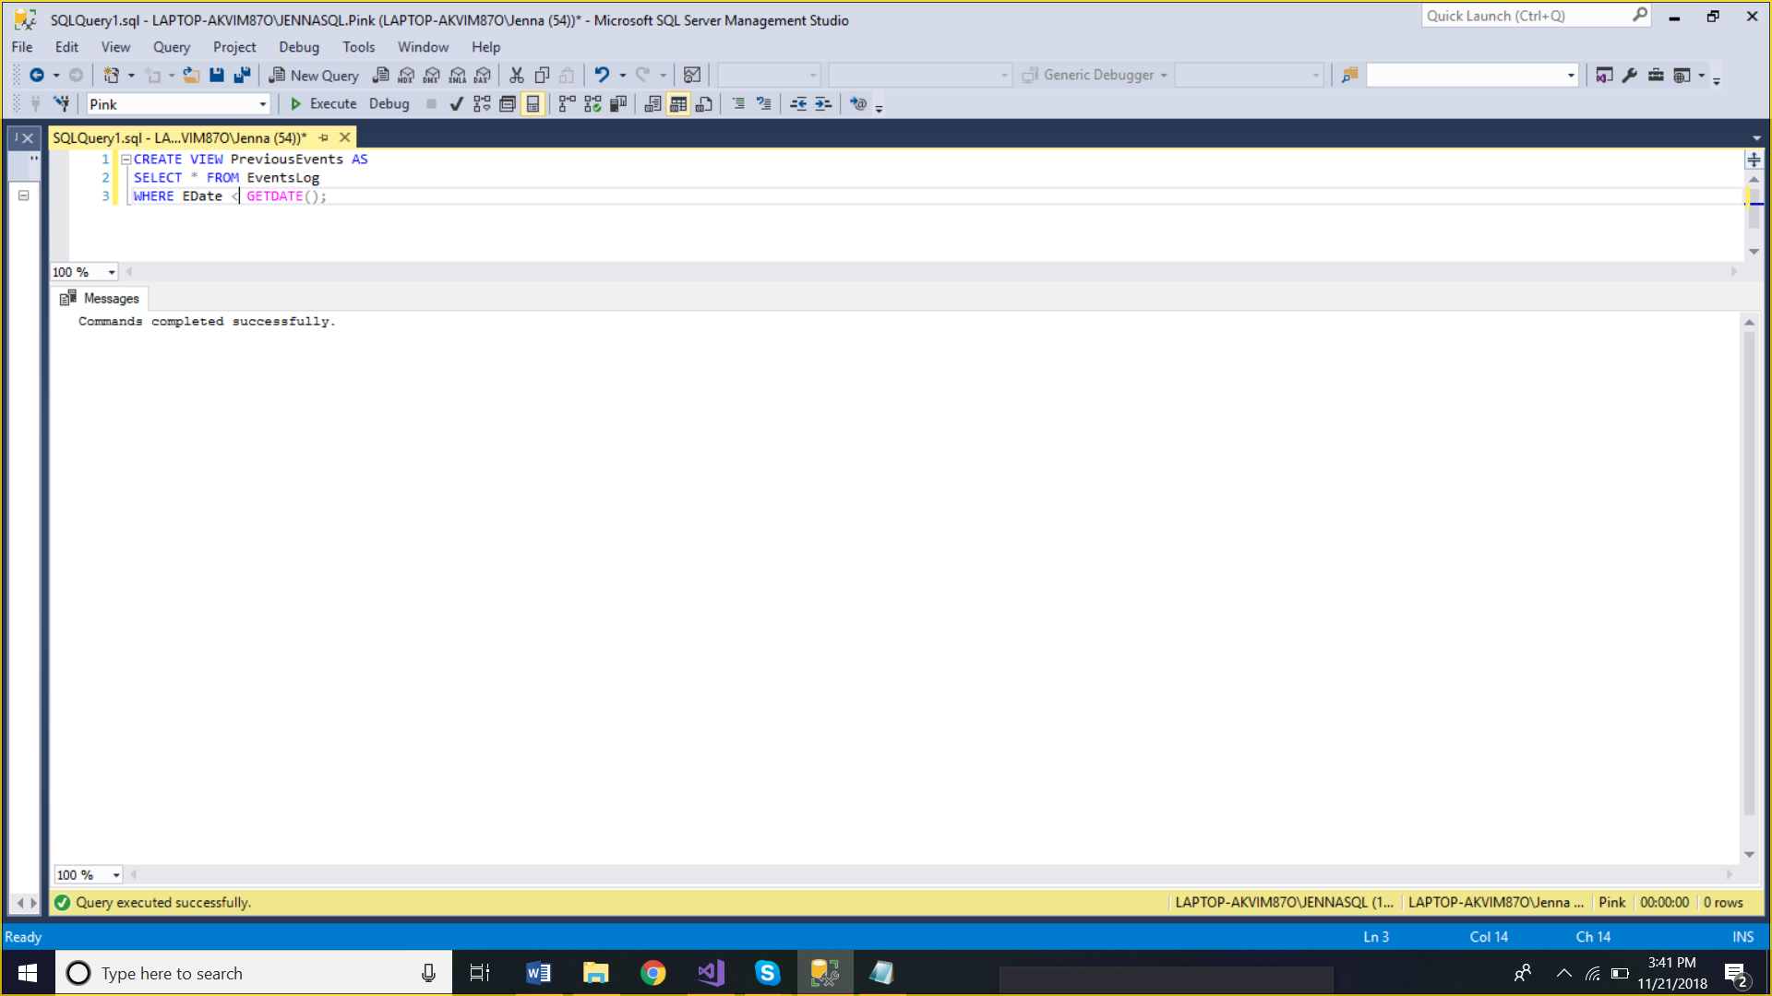

CREATE VIEW PreviousEvents AS

SELECT * FROM EventsLog

WHERE EDate < GETDATE();

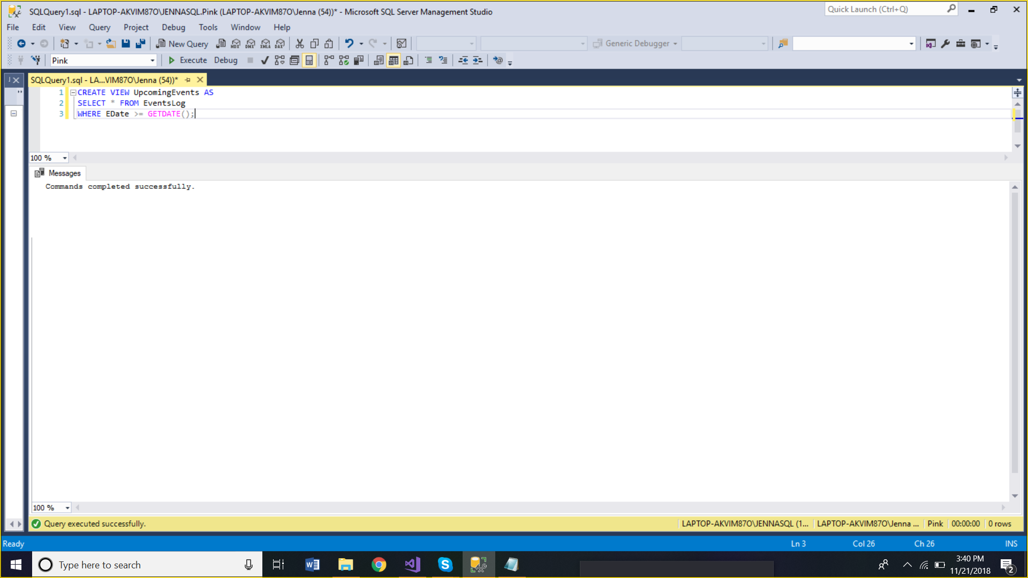

CREATE VIEW UpcomingEvents AS

SELECT * FROM EventsLog

WHERE EDate >= GETDATE();

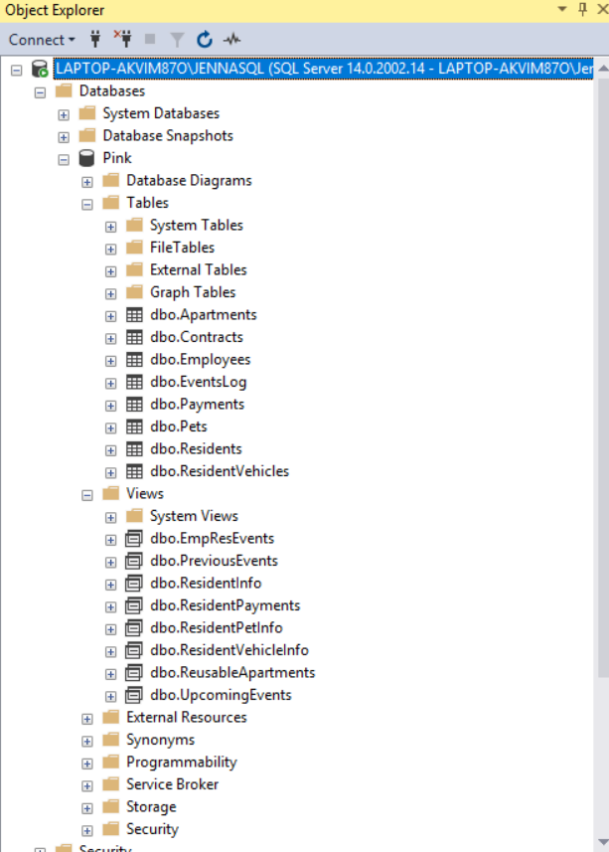

**Data Model** (Tyler Hodzen, Jenna Lovett, Troy Purvis)

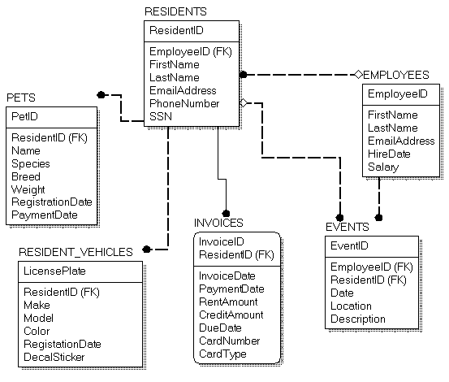

Version 1

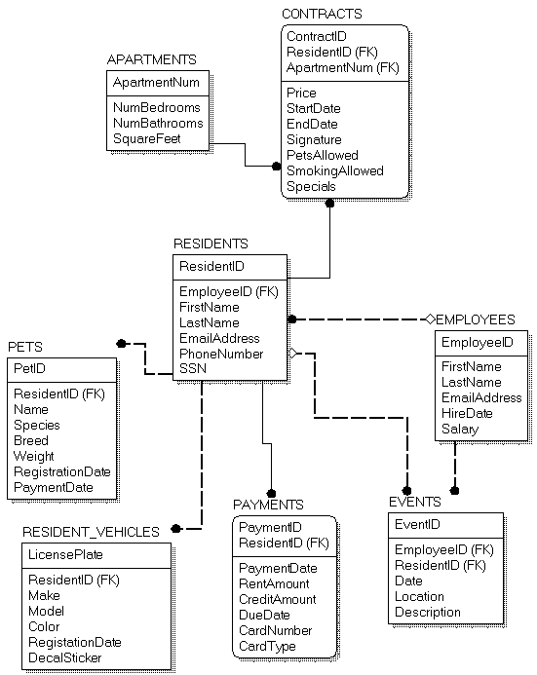

Version 2



Version 3 – Final Version



**Collective 10 Questions** (Jenna Lovett, Tyler Hodzen, Troy Purvis)

Jenna Lovett | Residents and Pets

1. Which residents own dogs?

use Pink;

SELECT FirstName, Breed, Species

FROM Residents JOIN Pets ON Residents.ResidentID = Pets.ResidentID

GROUP BY FirstName, Breed, Species HAVING Species = 'Dog';

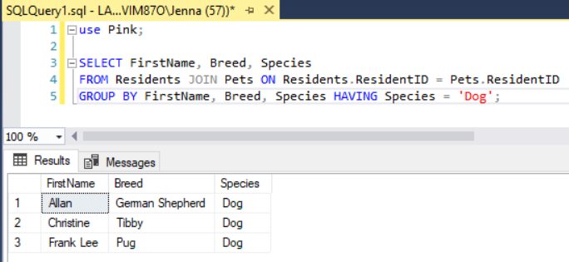

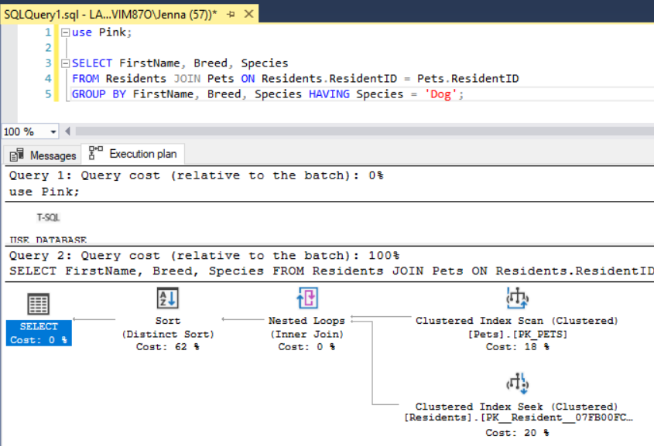

1. What is the number of species?

use Pink;

SELECT Species, Count(Species) AS NumOfSpecies

FROM PETS

GROUP BY Species;

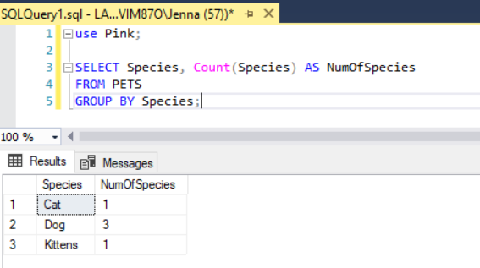

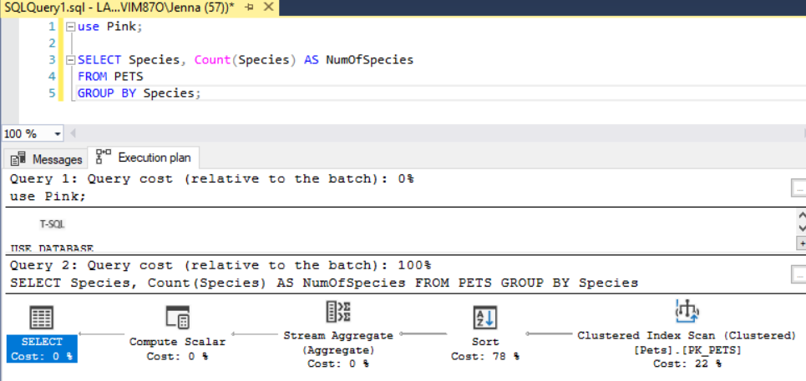

1. Who are the past residents who no longer reside at Pink Apartments?

use Pink;

SELECT FirstName + ' ' + LastName AS ResidentName, EndDate

FROM Residents JOIN Contracts ON Residents.ResidentID = Contracts.ResidentID

GROUP BY FirstName + ' ' + LastName, EndDate HAVING EndDate < GETDATE();

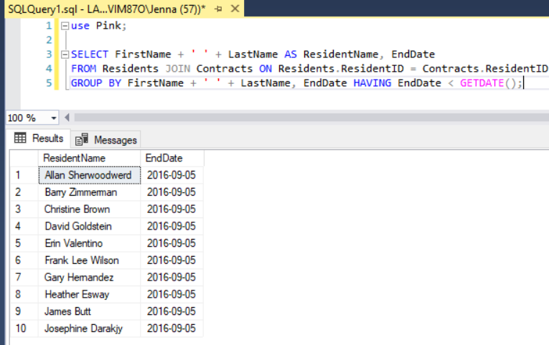

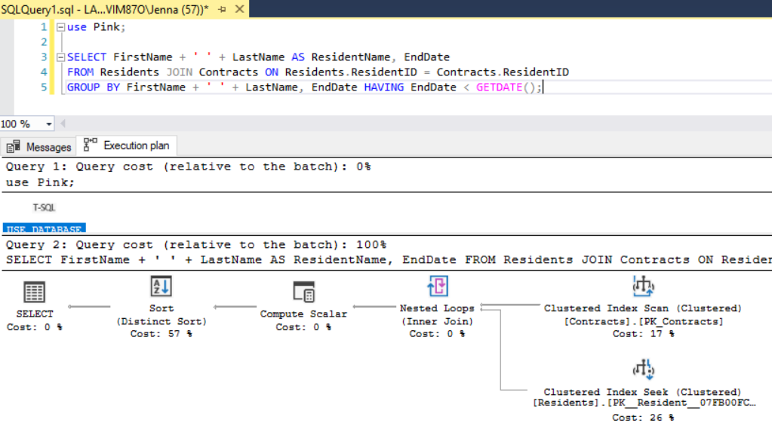

1. Who are the residents with last names between B and L and first names between J and R?

use Pink;

SELECT FirstName, LastName

FROM Residents

WHERE LastName BETWEEN 'B' AND 'L' AND FirstName BETWEEN 'J' AND 'R';

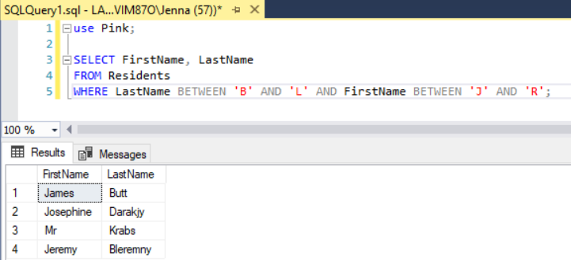

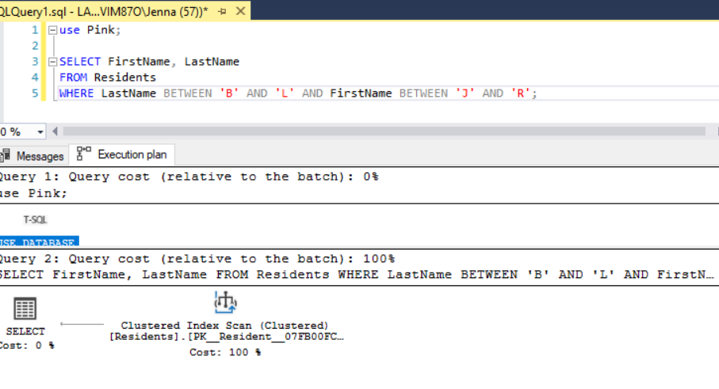

1. Which resident lives in apartment 101 and do they have pets?

use Pink;

SELECT ApartmentNum, FirstName, LastName, Breed, Species

FROM Residents JOIN Contracts ON Residents.ResidentID = Contracts.ContractID

JOIN Pets ON Residents.ResidentID = Pets.ResidentID

WHERE ApartmentNum = '101';

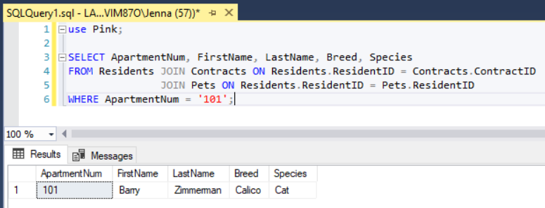

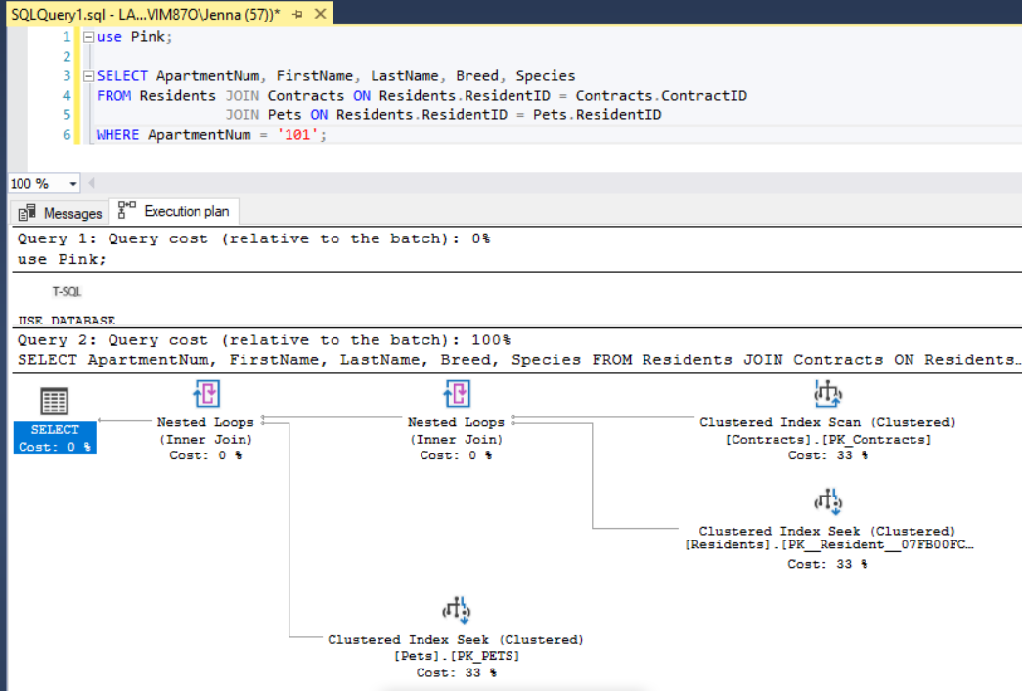

1. Which apartment units allow pets and what is the number of beds and baths?

use Pink;

SELECT DISTINCT Apartments.ApartmentNum, NumBeds, NumBaths, PetsAllowed

FROM Apartments JOIN Contracts ON Apartments.ApartmentNum = Contracts.ApartmentNum

WHERE PetsAllowed = 1;

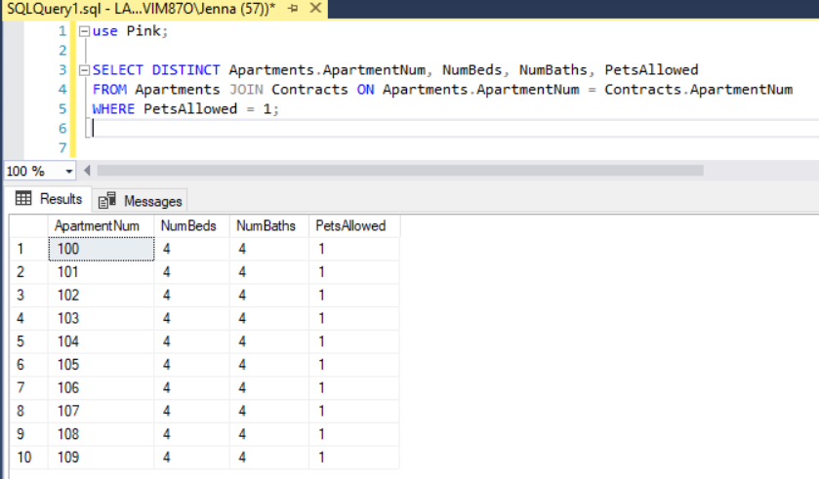

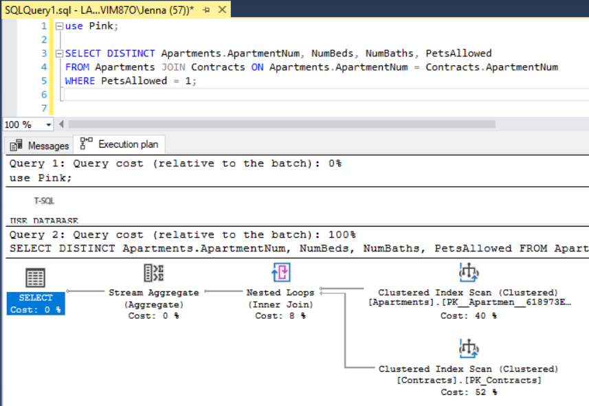

1. What is the average start date month for a contract by apartment number?

use Pink;

SELECT ApartmentNum, AVG(MONTH(StartDate)) AS AverageStartDate

FROM Contracts

GROUP BY ApartmentNum;

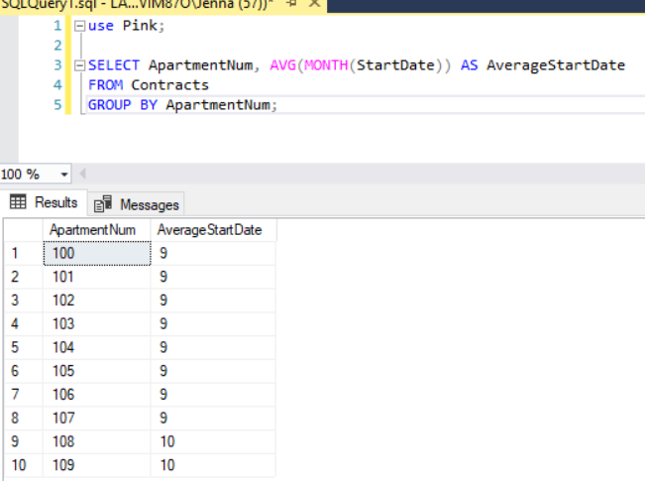

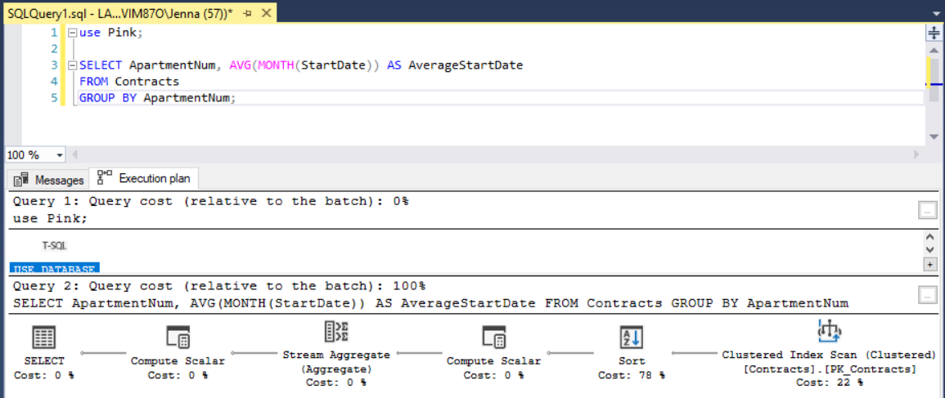

1. How many residents own pets?

use Pink;

SELECT ApartmentNum, FirstName, Species

FROM Residents JOIN Contracts ON Contracts.ResidentID = Residents.ResidentID

JOIN Pets ON Residents.ResidentID = Pets.ResidentID;

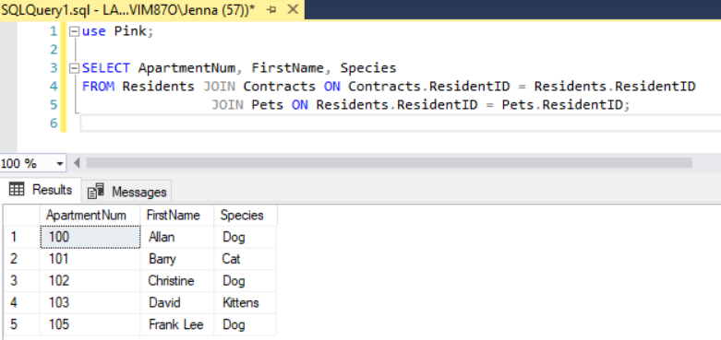

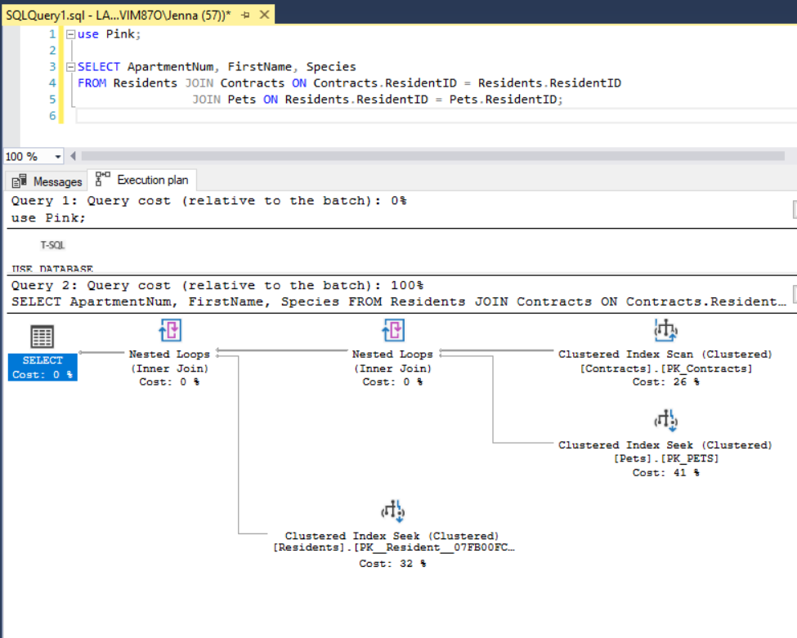

1. Which contracts have a base rent price of $1000.00?

use Pink;

SELECT ContractID, Price

FROM Contracts

WHERE Price = 1000.00;

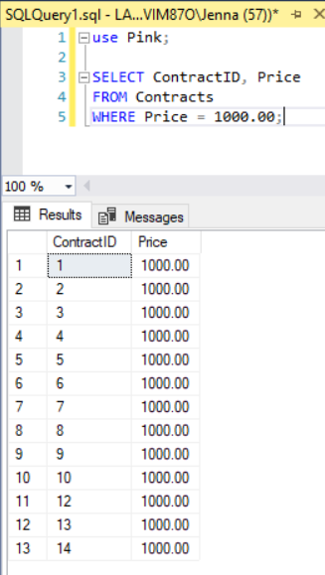

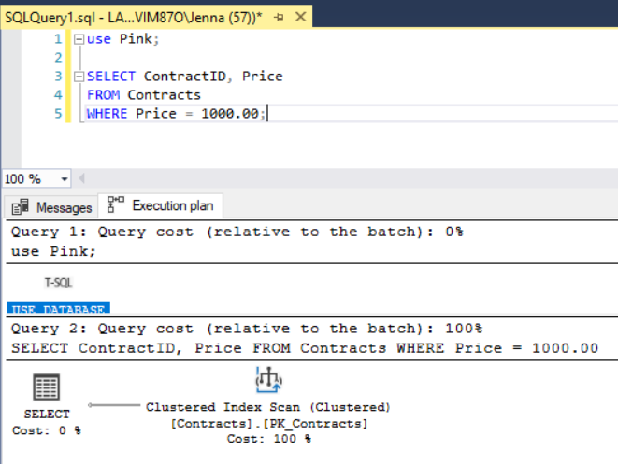

1. Which residents are from the region of the state where the area code is 555?

use Pink;

SELECT FirstName, LastName, EmailAddress, PhoneNumber

FROM Residents

GROUP BY FirstName, LastName, EmailAddress, PhoneNumber HAVING LEFT(PhoneNumber, 3) = '555';

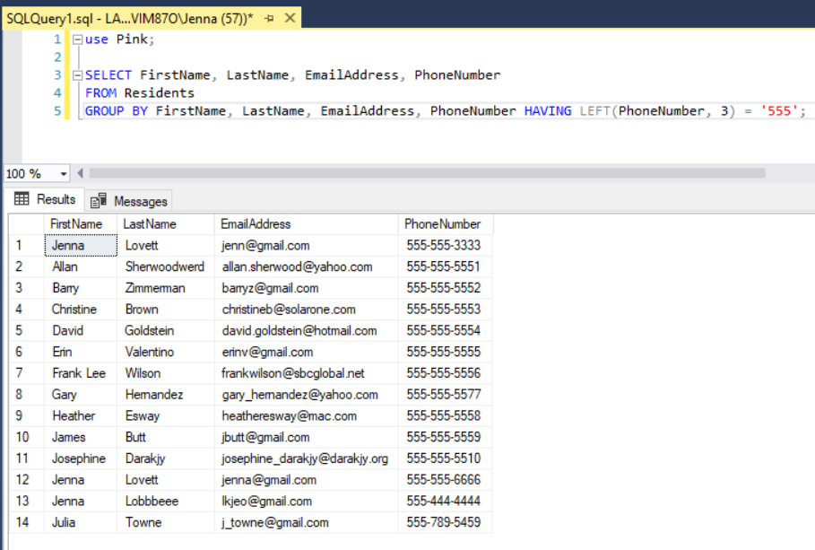

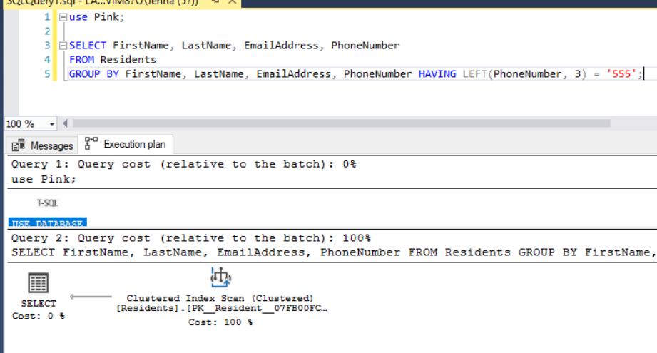

Troy Purvis | Vehicles and Events tables

1. Return all vehicles with the same make/model/color (include resident ID, Make, model, & Color) where the make is Honda.

use Pink;

SELECT ResidentID, Make, Model, Color

FROM ResidentVehicles

WHERE Make = 'Ford';

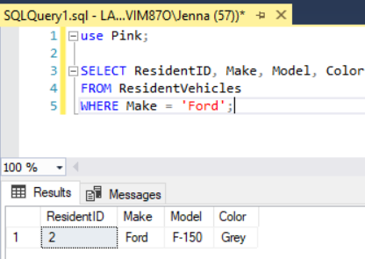

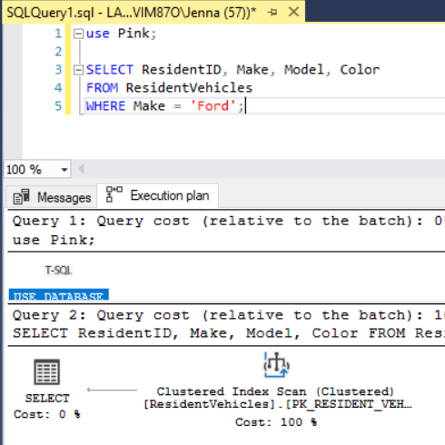

1. Return a specific vehicle’s info given the decal sticker or license plate number

use Pink;

SELECT LicensePlate, ResidentID, Make, Model, Color

FROM ResidentVehicles

WHERE LicensePlate = 'pgs3222';

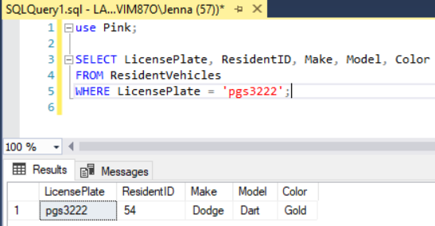

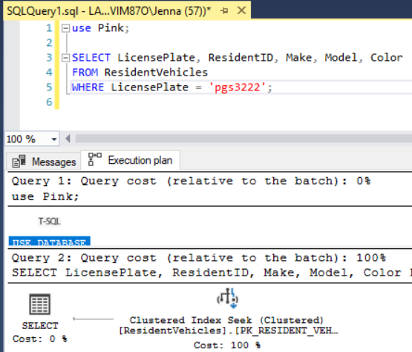

1. Return all residents with a valid registered vehicle (registration dates could expire in some arbitrary time frame)

use Pink;

SELECT rv.ResidentID, r.FirstName, r.LastName

FROM ResidentVehicles rv JOIN Residents r ON rv.ResidentID = r.ResidentID

WHERE DATEADD(year, 1, rv.RegistrationDate) > GETDATE();

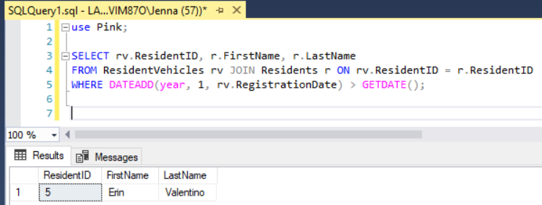

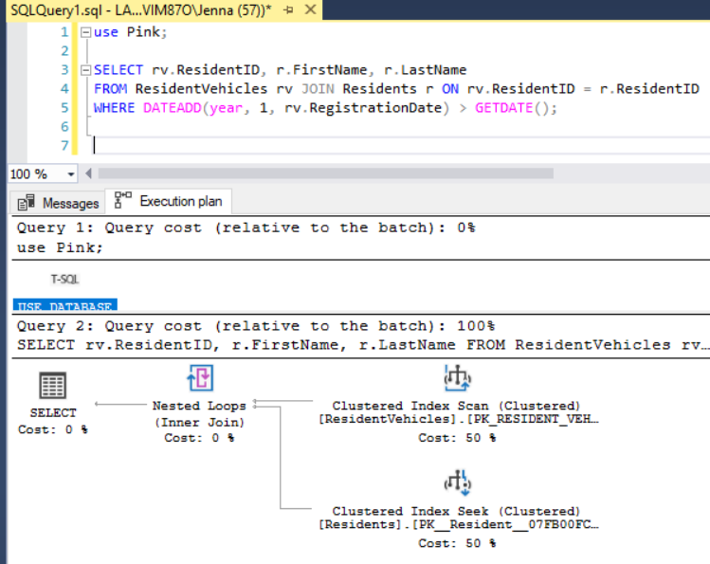

1. Return all vehicles that have a certain pattern in their license plate (use left)

use Pink;

SELECT LicensePlate, Make, Model, Color

FROM ResidentVehicles

WHERE LEFT(LicensePlate, 1) = 'a';

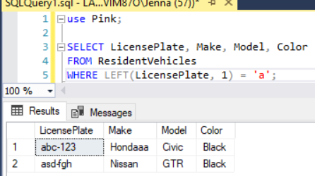

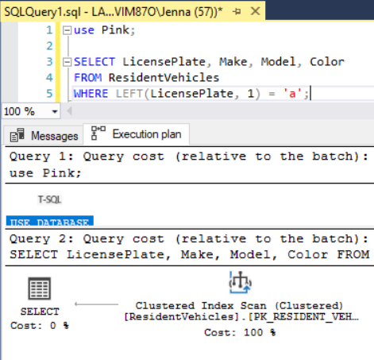

1. Return all vehicles that have a registration date that has expired or will be expiring soon

use Pink;

SELECT LicensePlate, ResidentID, Make, Model, Color, RegistrationDate

FROM ResidentVehicles

WHERE DATEADD(year, 1, RegistrationDate) < GETDATE();

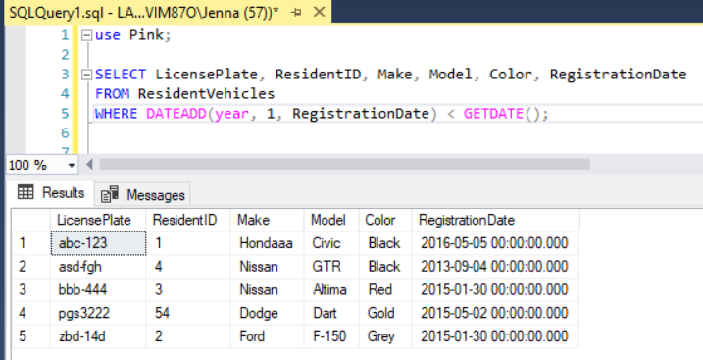

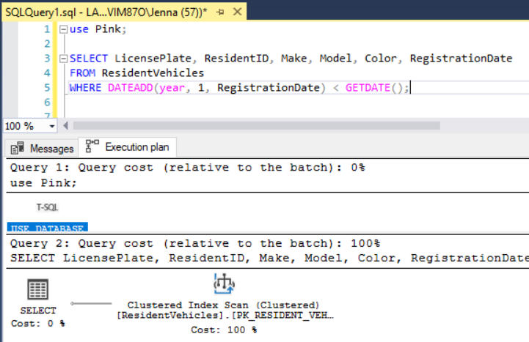

1. Return only employees and their vehicles that have valid registration dates (not residents)

use Pink;

SELECT r.FirstName, r.LastName, r.EmployeeID, rv.Make, rv.Model, rv.Color, rv.LicensePlate

FROM ResidentVehicles rv JOIN Residents r ON rv.ResidentID = r.ResidentID

WHERE r.EmployeeID IS NOT NULL AND DATEADD(year, 1, rv.RegistrationDate) > GETDATE();

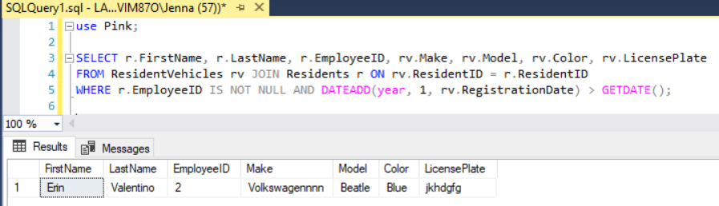

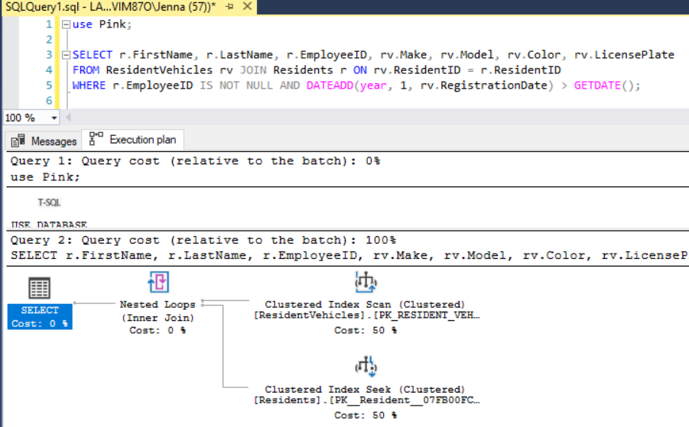

1. Return all vehicles that were registered on a specific day/month/year (Prefix matching)

use Pink;

SELECT LicensePlate, Make, Model, Color, RegistrationDate

FROM ResidentVehicles

WHERE MONTH(RegistrationDate) = 9;

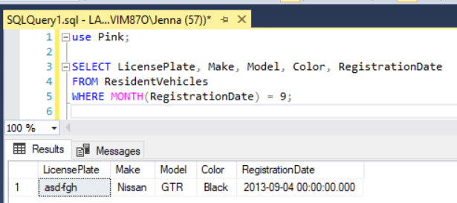

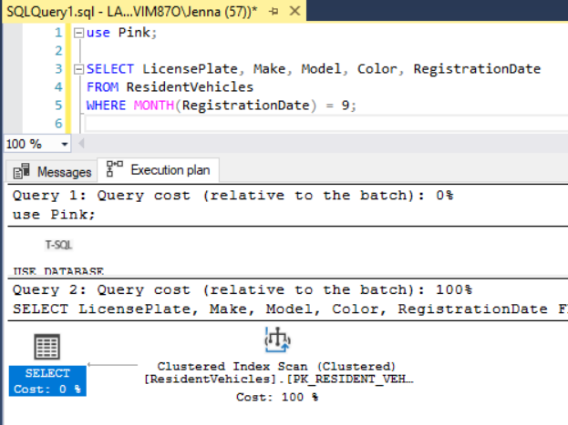

1. Return all events happening in the next day/month/year

use Pink;

SELECT EventID, Edate, Elocation

FROM EventsLog

WHERE Edate >= GETDATE() AND DATEADD(month, -1, Edate) <= GETDATE();

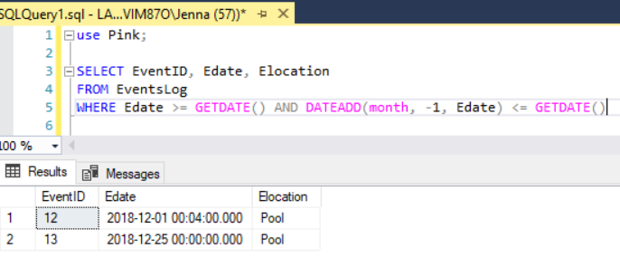

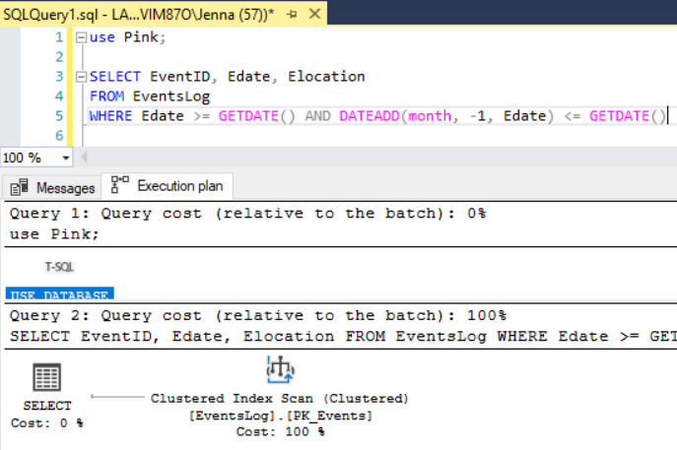

1. Return all vehicles that are owned by a resident with a pet

use Pink;

SELECT rv.licenseplate, rv.make, rv.model, rv.color

FROM ResidentVehicles rv JOIN Pets p ON p.ResidentID = rv.ResidentID;

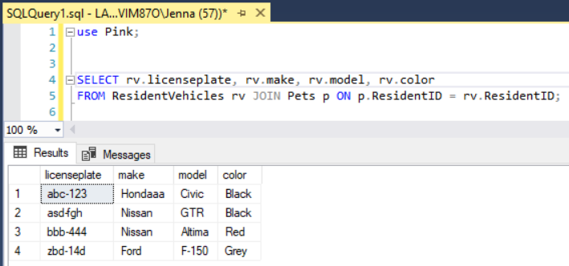

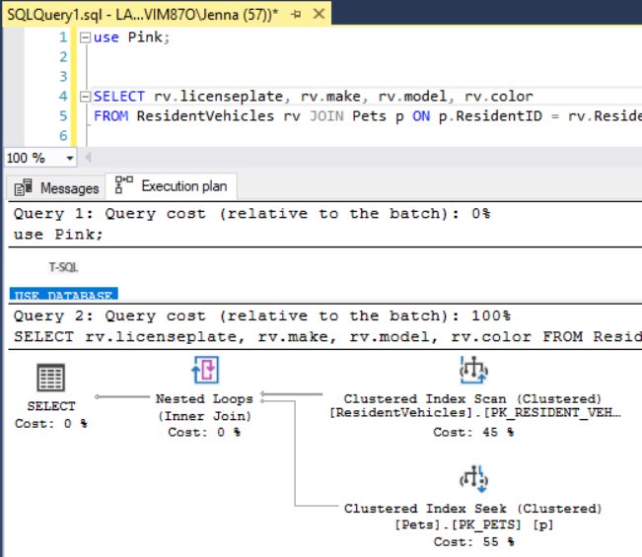

1. Return the vehicles of people with apartment sizes > 1000 square feet

use Pink;

SELECT rv.LicensePlate, rv.make, rv.model, rv.color

FROM ResidentVehicles rv JOIN Contracts c ON rv.ResidentID = c.ResidentID

JOIN Apartments a ON c.Apartmentnum = a.apartmentnum

WHERE a.sqft >= 1000;

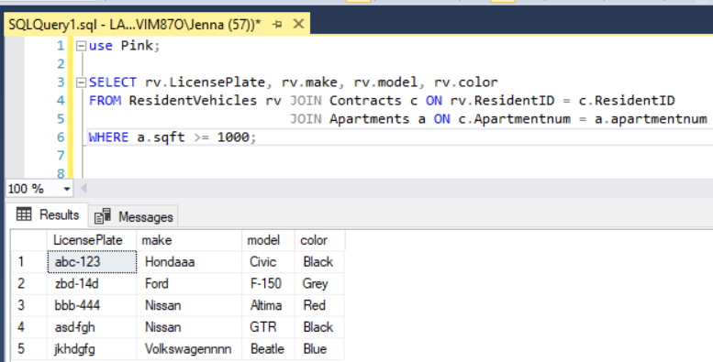

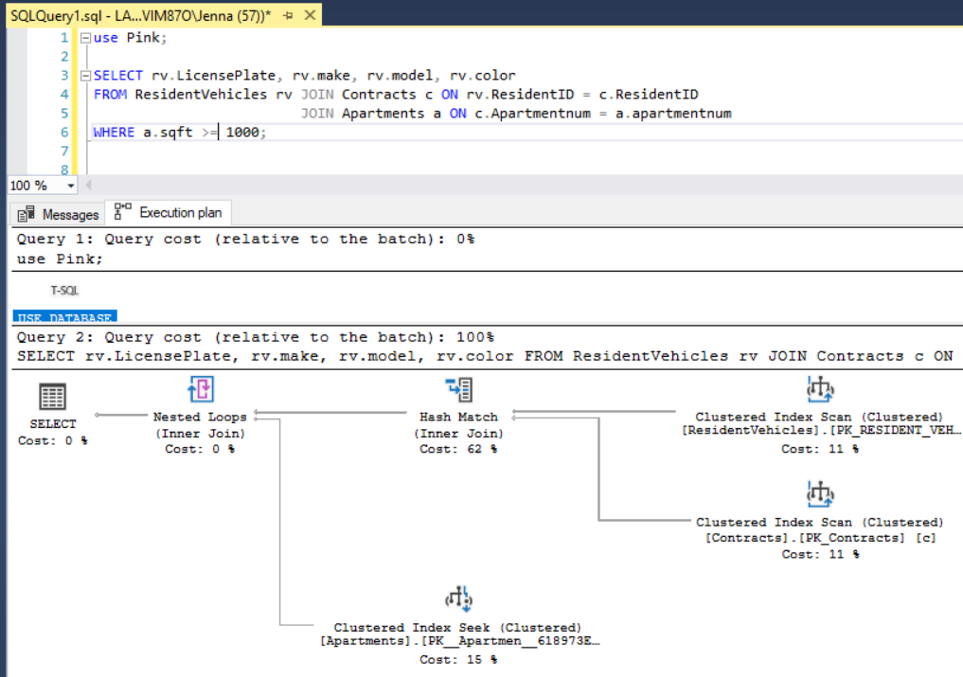

Tyler Hodzen | Maintenance and Employees

1. How many employees are a part of the Groundsman staff?

Select *

From Employees

Where JobTitle = 'Groundsman';

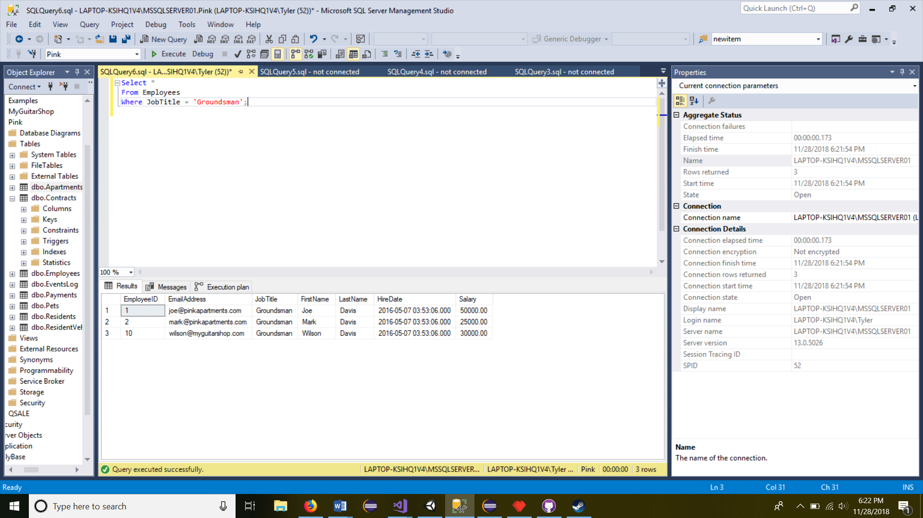

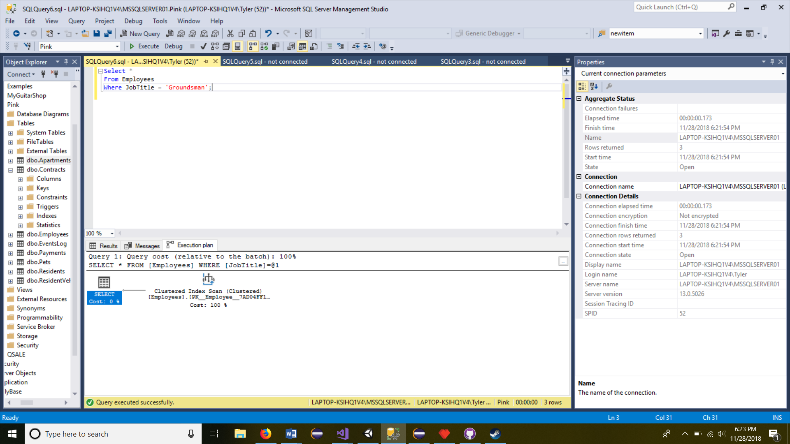

1. How many employees are residents of the Pink Apartments?

SELECT Count(*) as Employee FROM Residents Where EmployeeID is Not Null

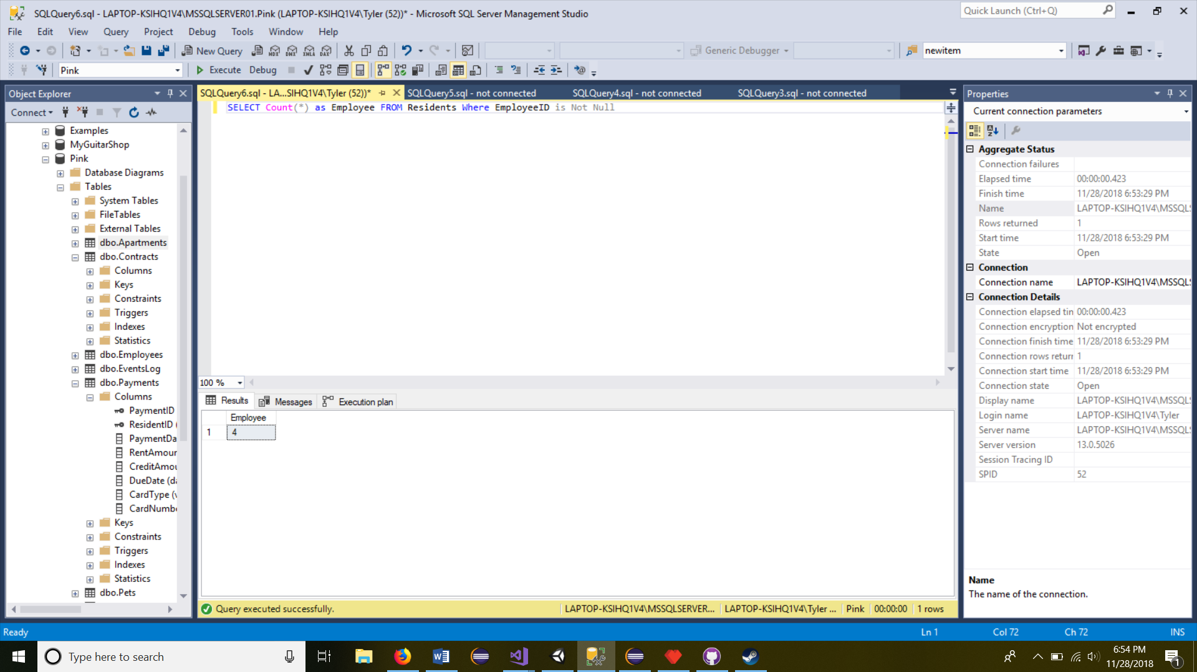

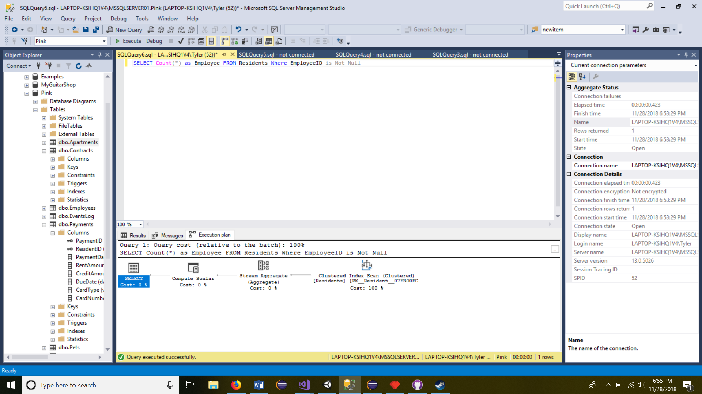

1. List the card types from most to least frequently used.

SELECT CardType

FROM Payments

GROUP BY CardType

ORDER BY COUNT(*) DESC;

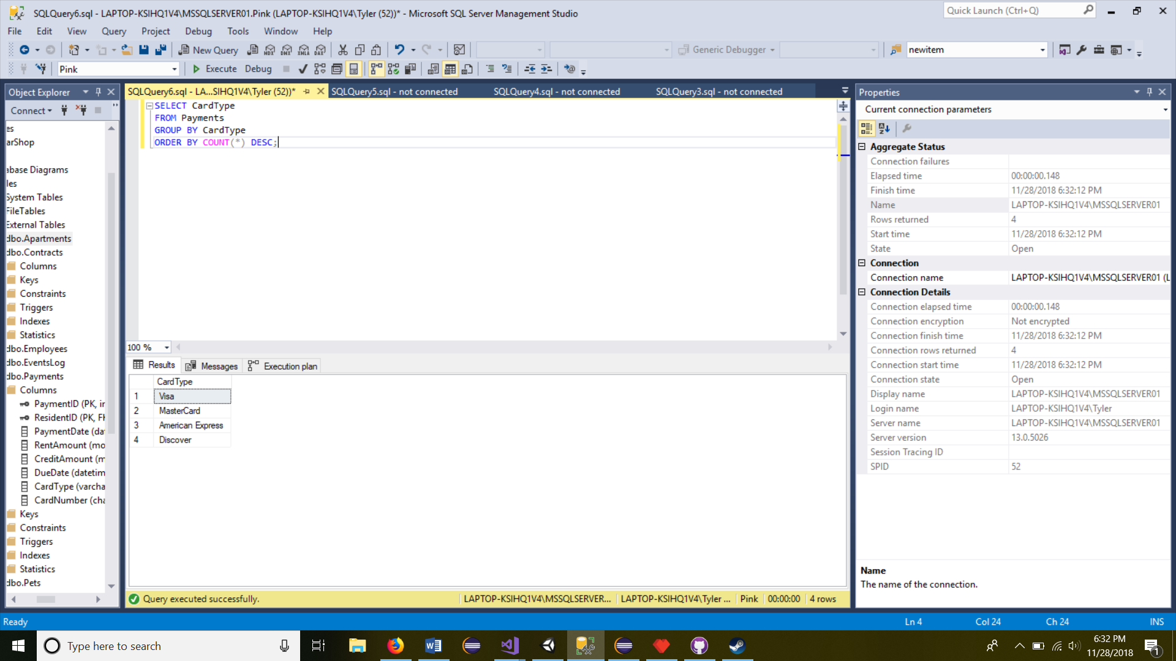

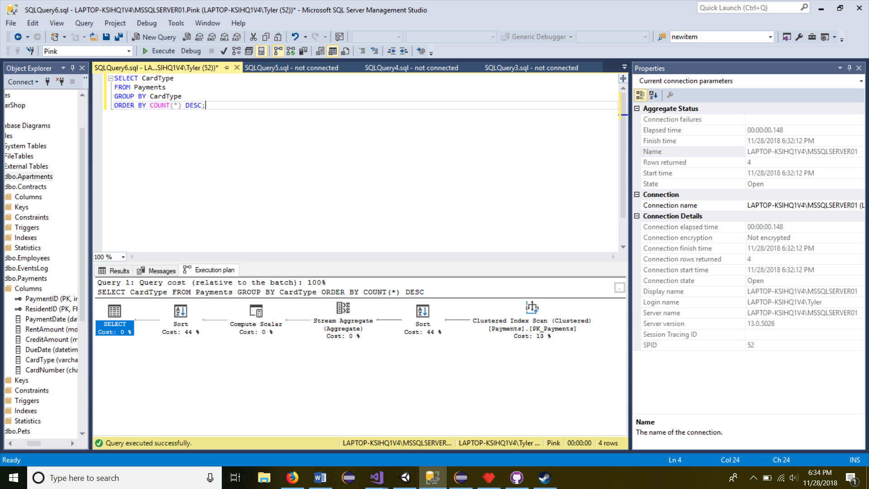

1. What is the average rent amount?

SELECT AVG(RentAmount) AS AveragePrice FROM Payments;

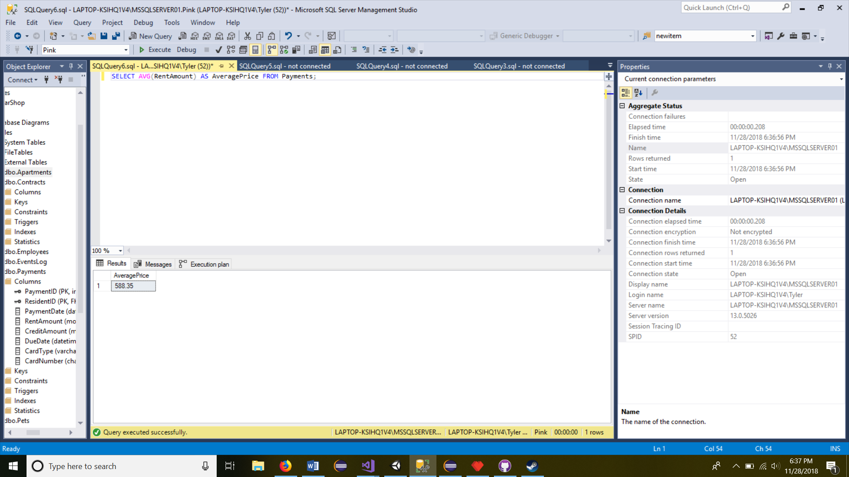

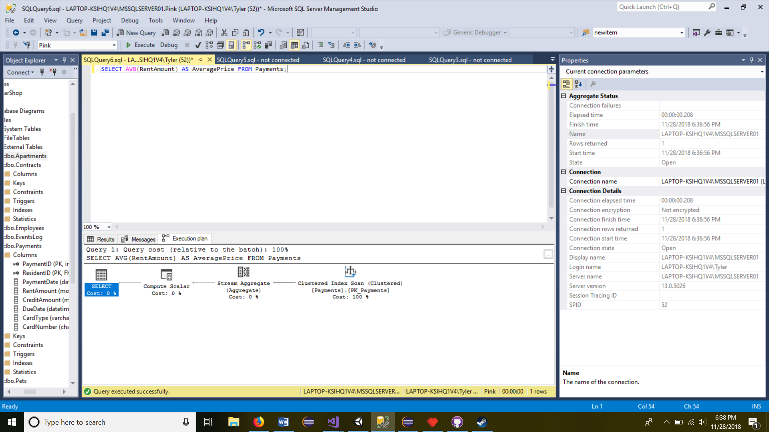

1. Which job position has the most employees?

SELECT JobTitle

FROM Employees

GROUP BY JobTitle

ORDER BY COUNT(*) DESC;

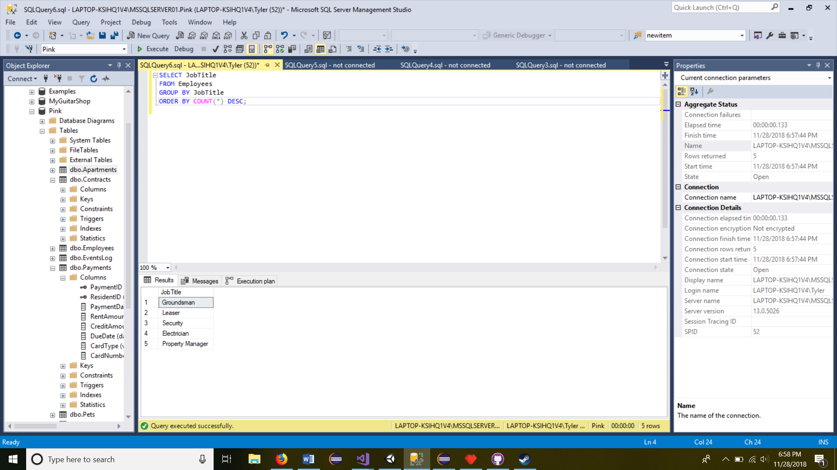

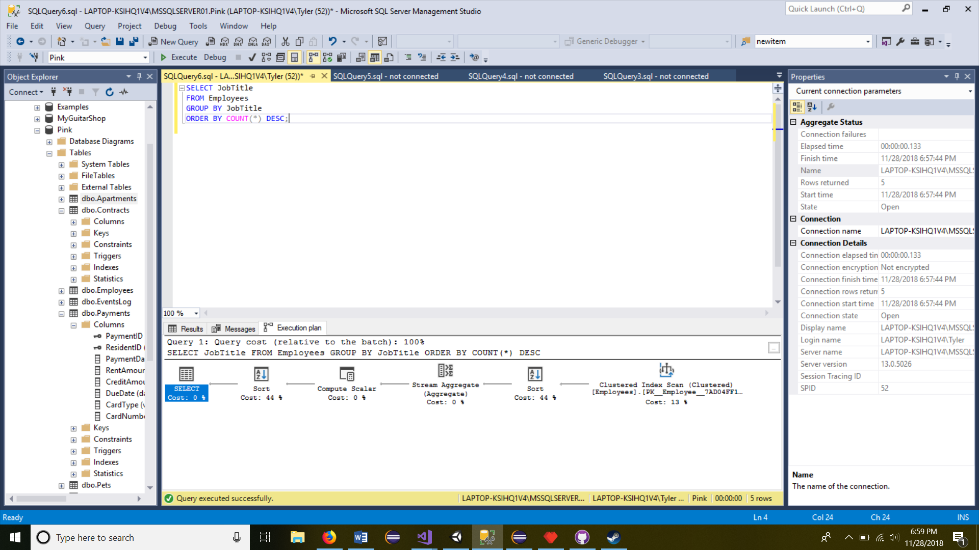

1. How many employees have worked events?

SELECT Count(*) as Employee FROM EventsLog Where EmployeeID is Not Null

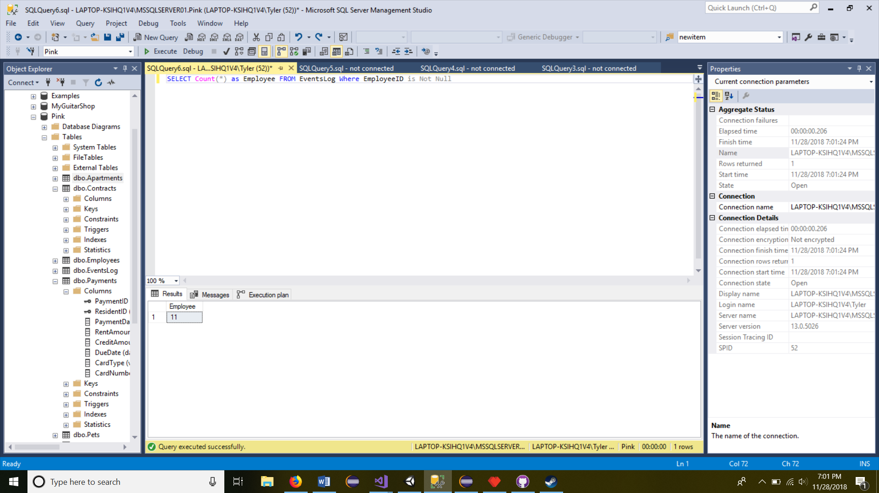

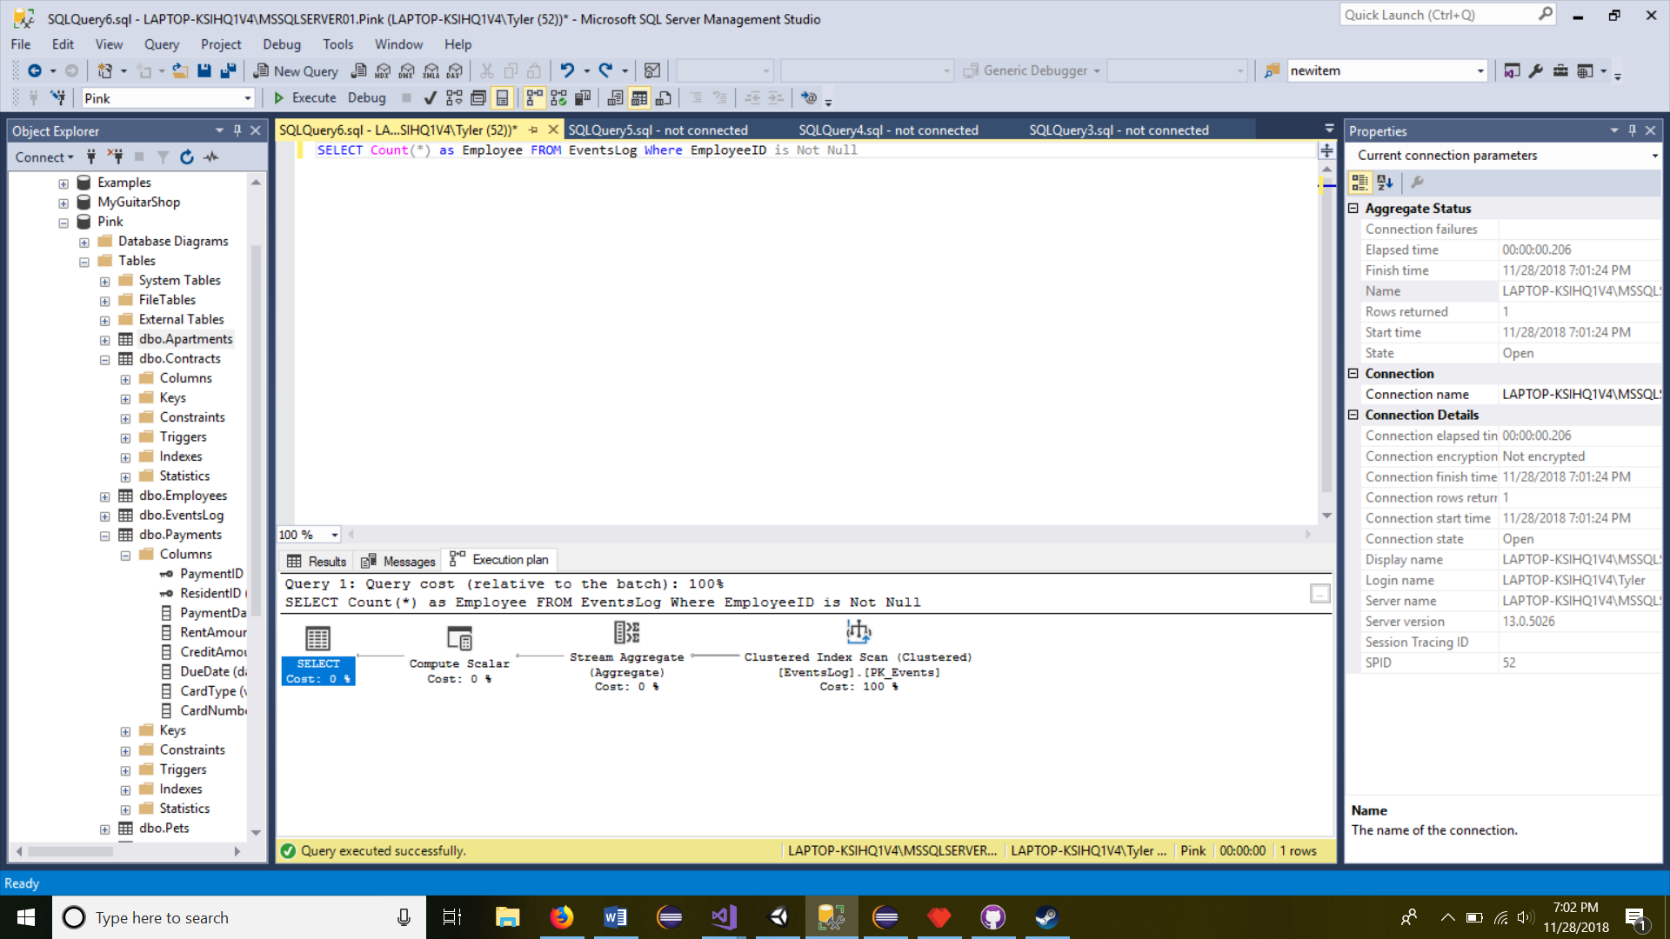

1. How many employees have registered a car with the apartment?

SELECT Count(*) as EmployeeVehiclesRegistered from Residents

join ResidentVehicles on Residents.ResidentID = ResidentVehicles.ResidentID

Where EmployeeID is Not Null

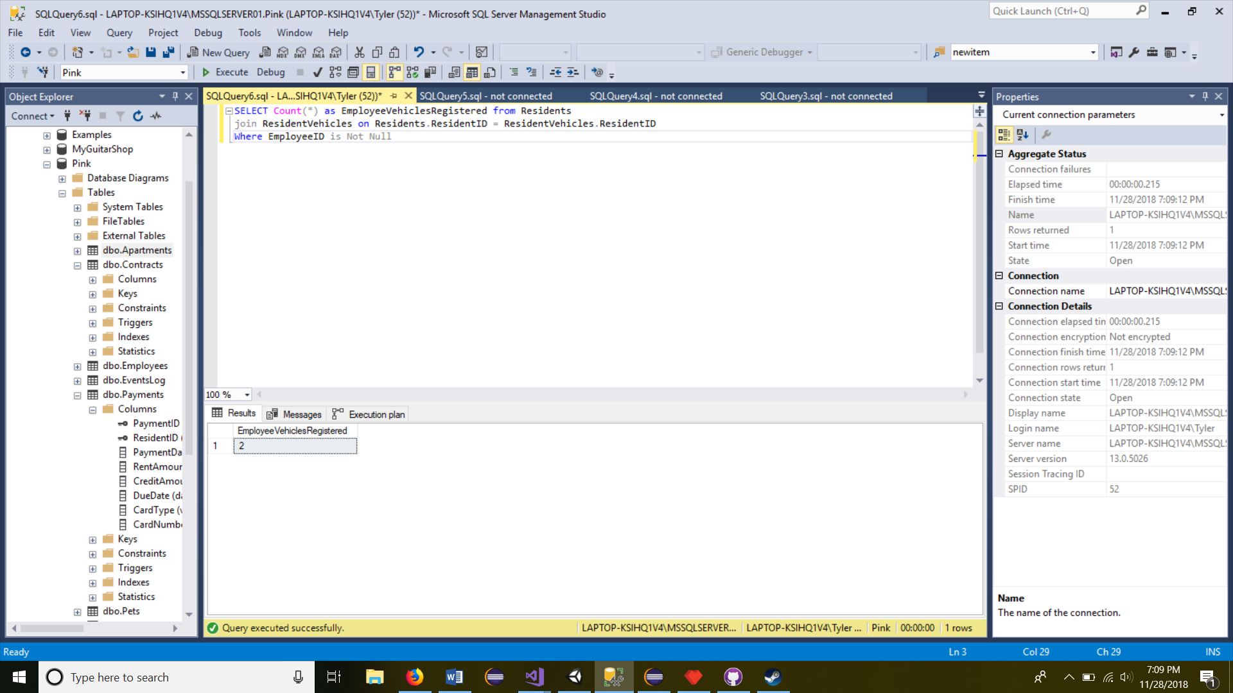

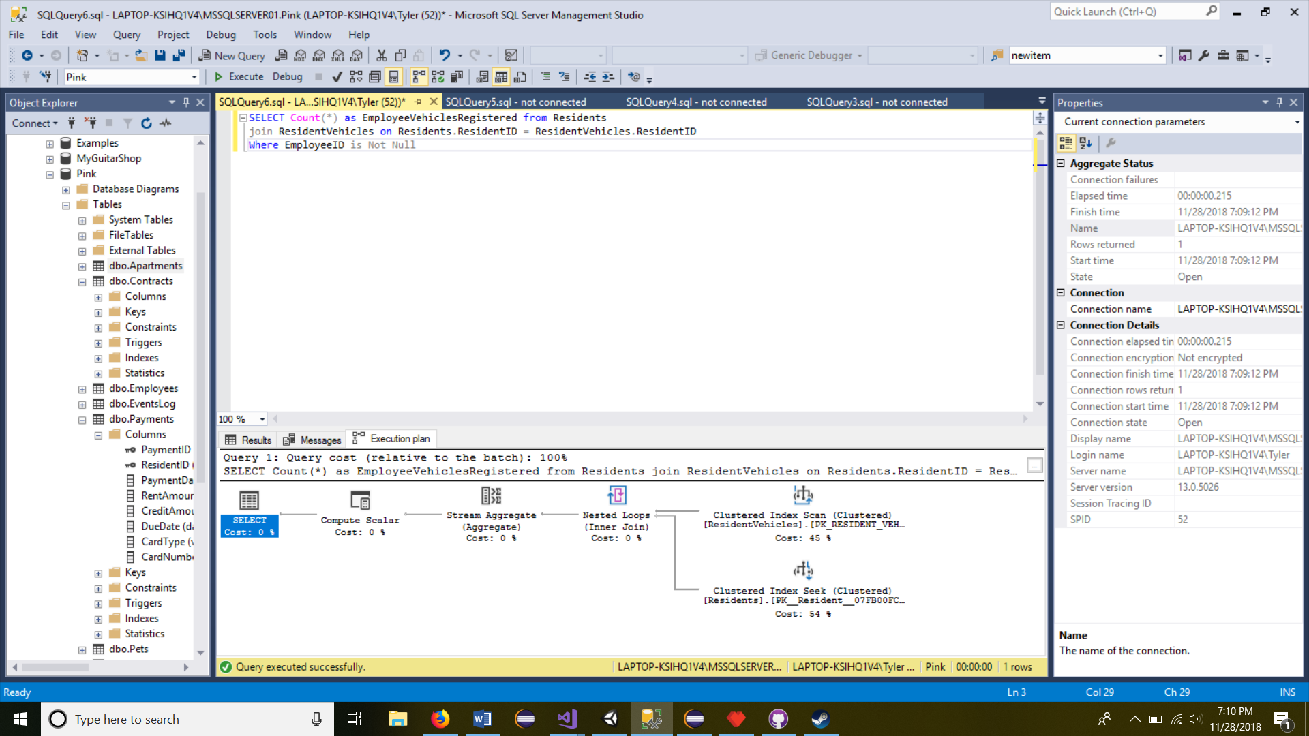

8. List the name of all employees starting with the employee who has been an employee the longest.

SELECT HireDate, EmployeeID, (FirstName + LastName) as Name

From Employees

Order by HireDate desc;

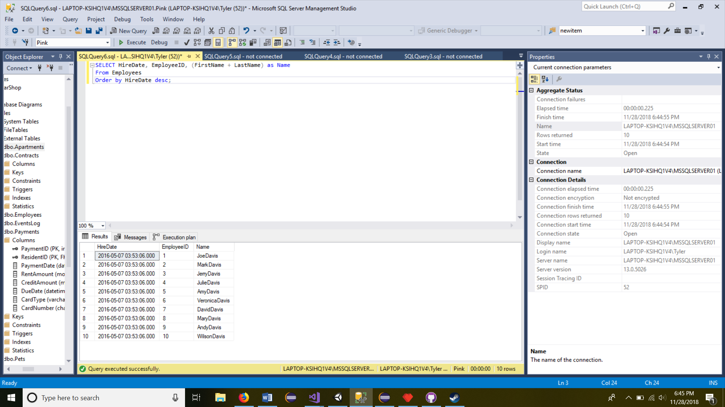

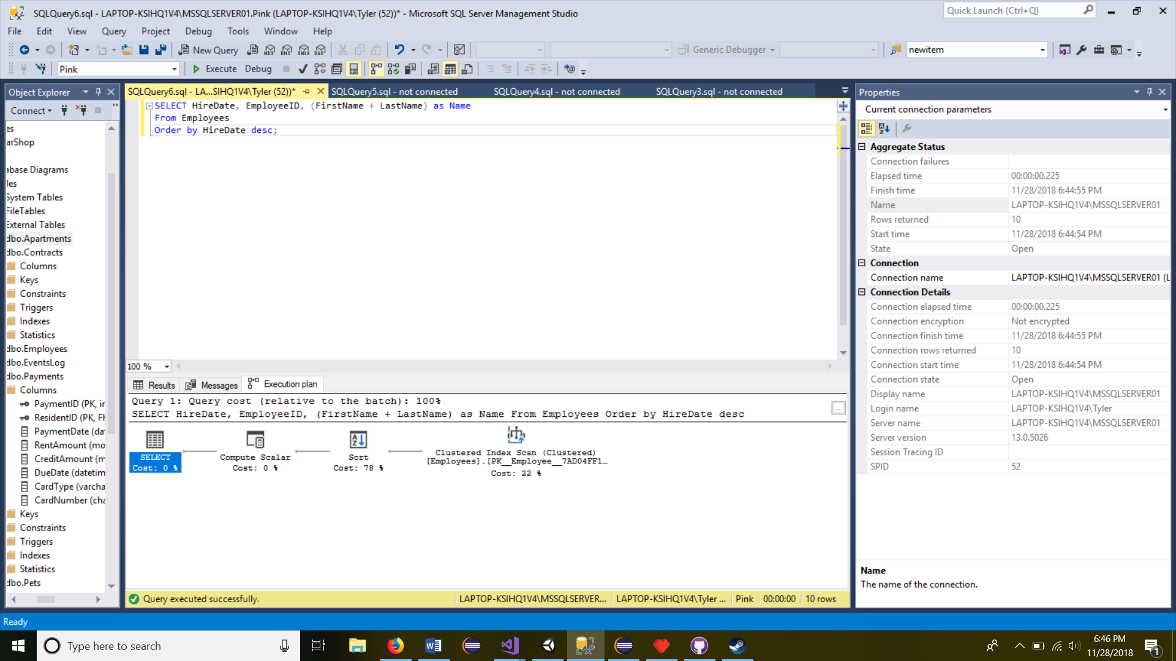

1. How many residents received a free Xbox

SELECT Count(*) as ReceivedAFreeXBox from Contracts

join Residents on Residents.ResidentID = Contracts.ResidentID

Where Specials = 'Free XBox'

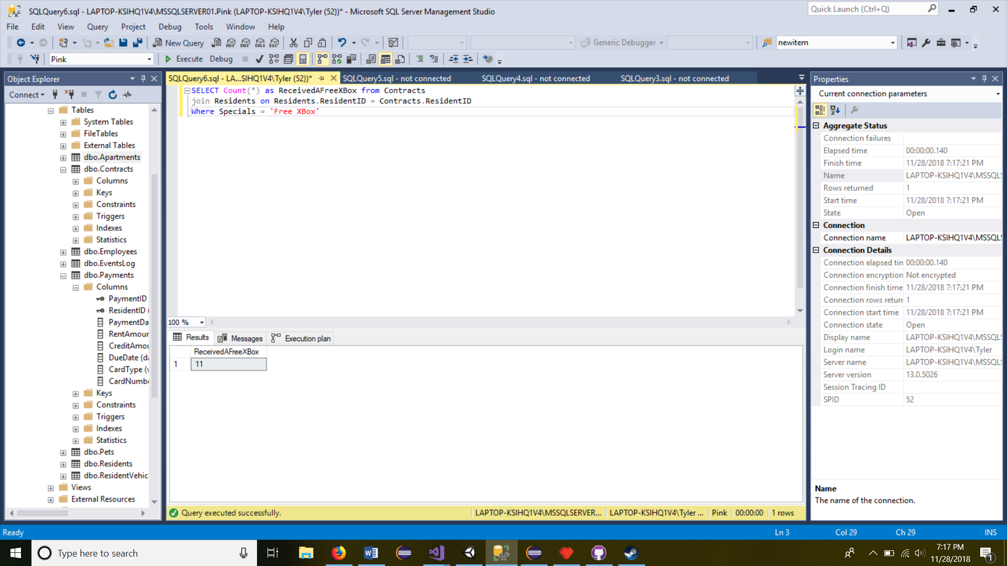

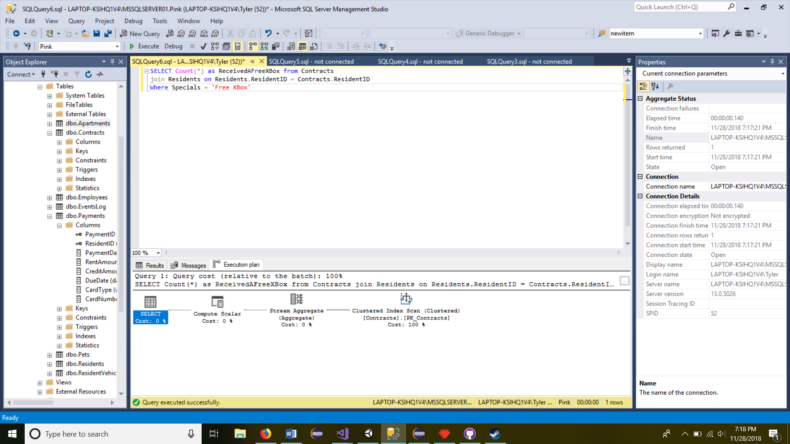

1. How many employees own pets?

SELECT Count(*) as PetsOwnedByEmployees from Pets

join Residents on Residents.ResidentID = Pets.ResidentID

Where EmployeeID is Not Null

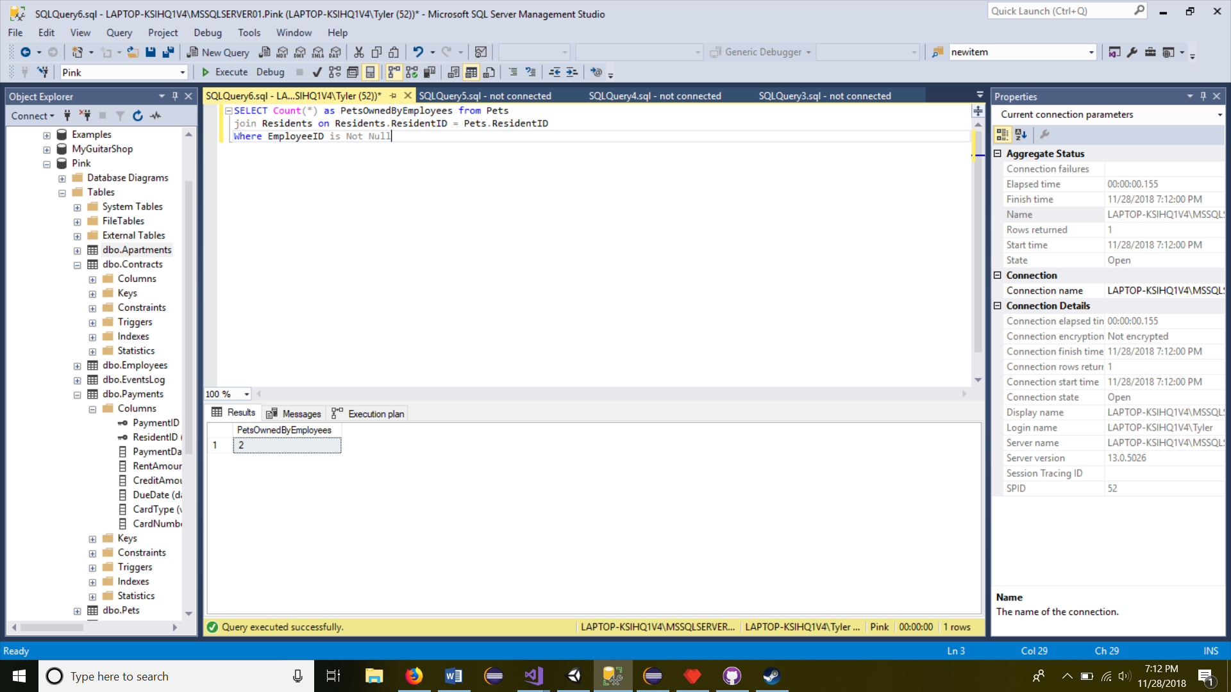

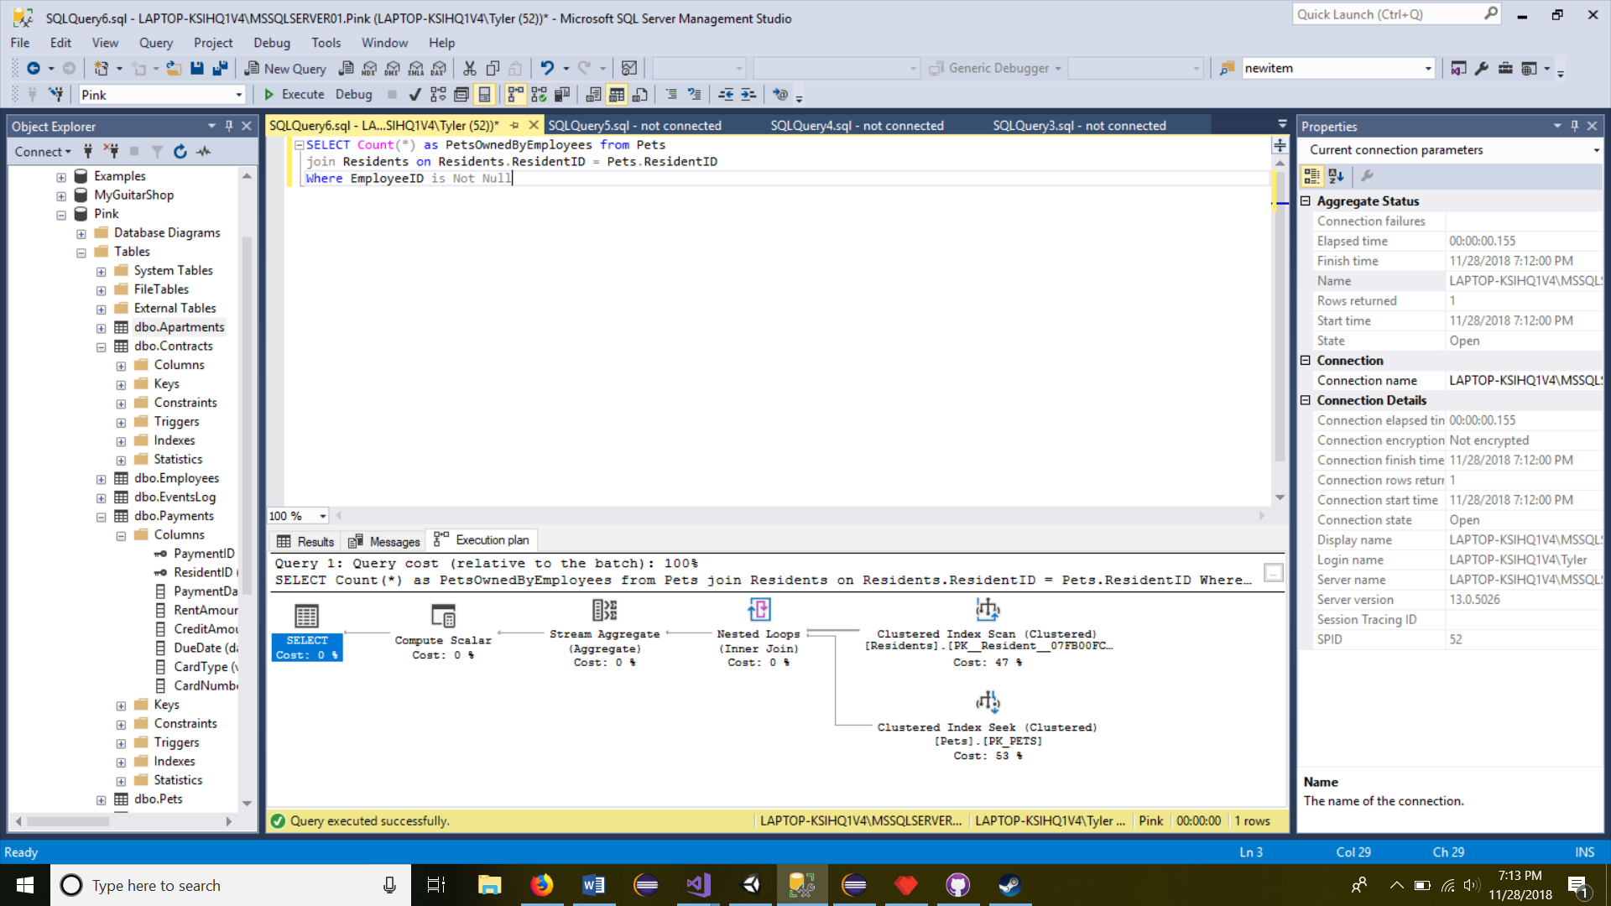

~~Dallas Martin | Invoices & Departments~~

1. ~~Which resident(s) have not paid their rent in full?~~
2. ~~Which resident(s) paid their rent more than three days late?~~
3. ~~What is the average rent amount among all residents in each floorplan?~~
4. ~~Which residents pay using a debit card?~~
5. ~~Which residents pay using a checking account?~~
6. ~~Which department has more than three employees?~~
7. ~~What are the names of individuals that are employees and residents?~~
8. ~~Which department was established the earliest?~~
9. ~~What are the names of each employee, listed by their department?~~
10. ~~Which resident has a monthly credit of more than $10?~~

**Mock UI**

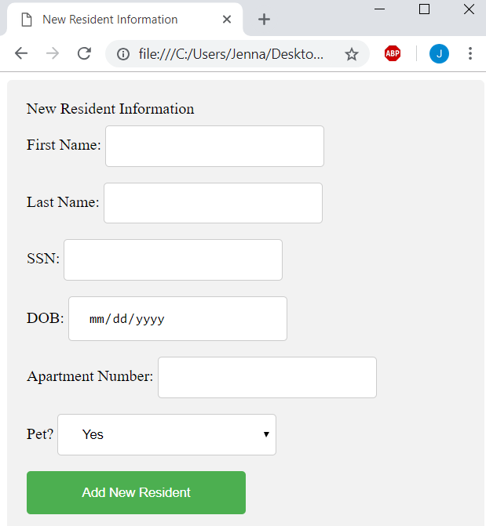Jenna Lovett | Residents and Pets

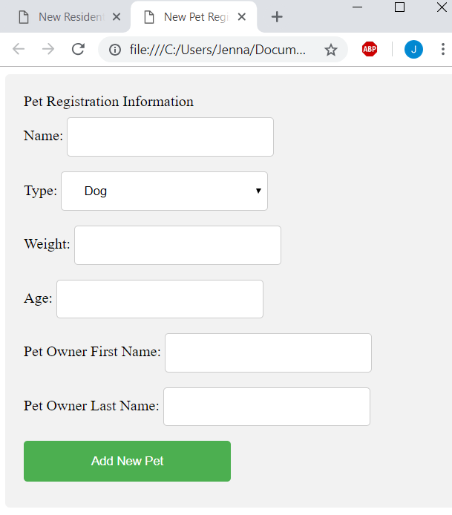

Tyler Hodzen |Employees and Maintenance

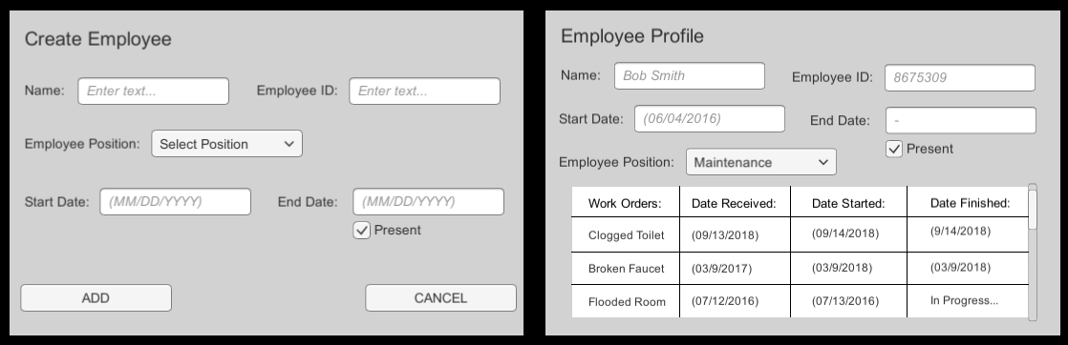

Troy Purvis | Events and Vehicles

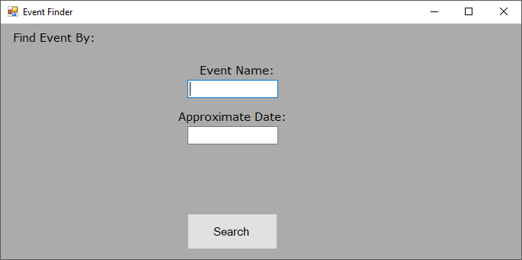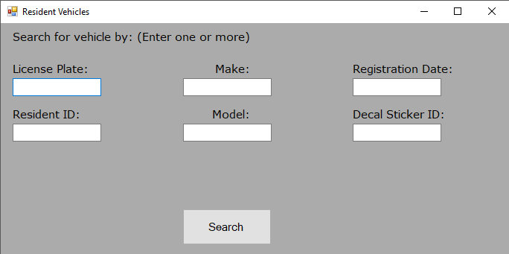

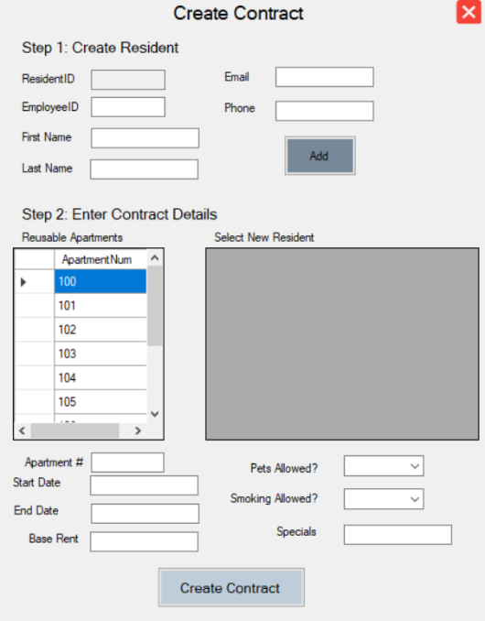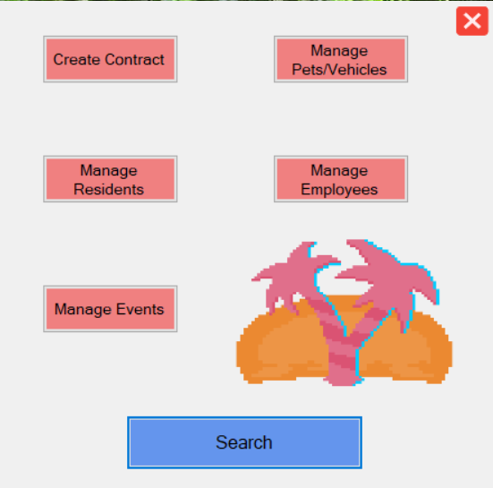**Final UI (**Tyler Hodzen, Troy Purvis, Jenna Lovett)

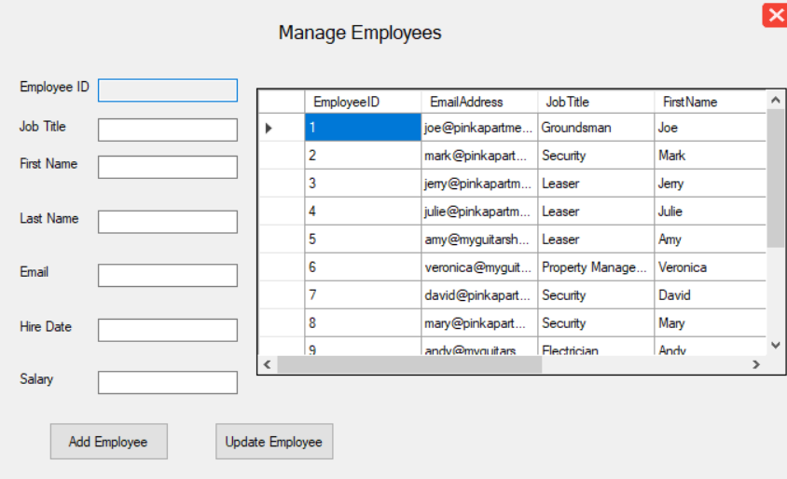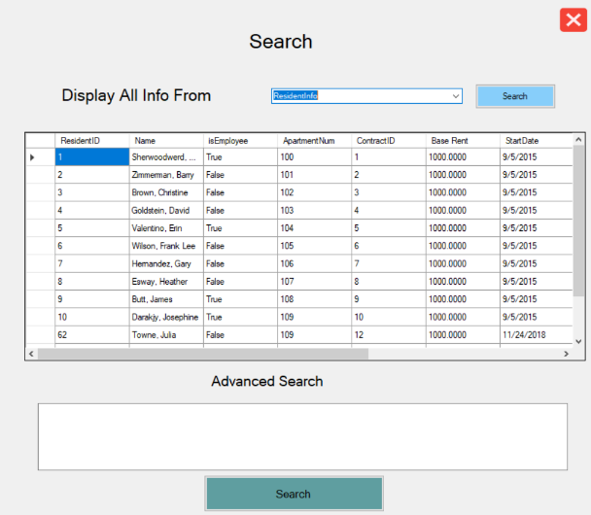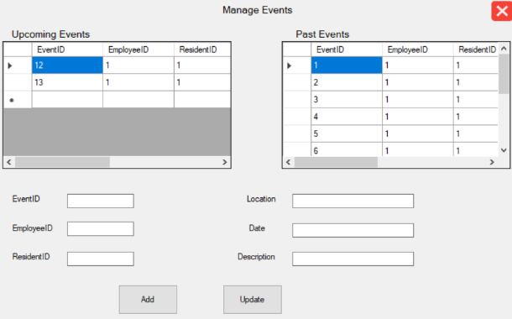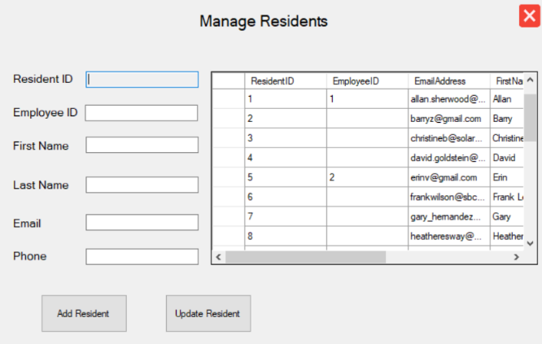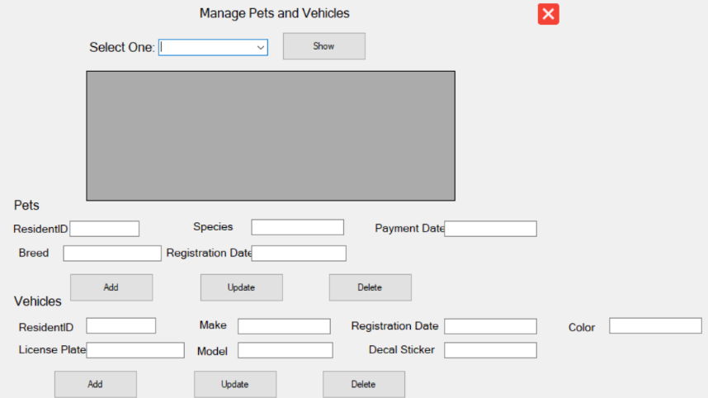

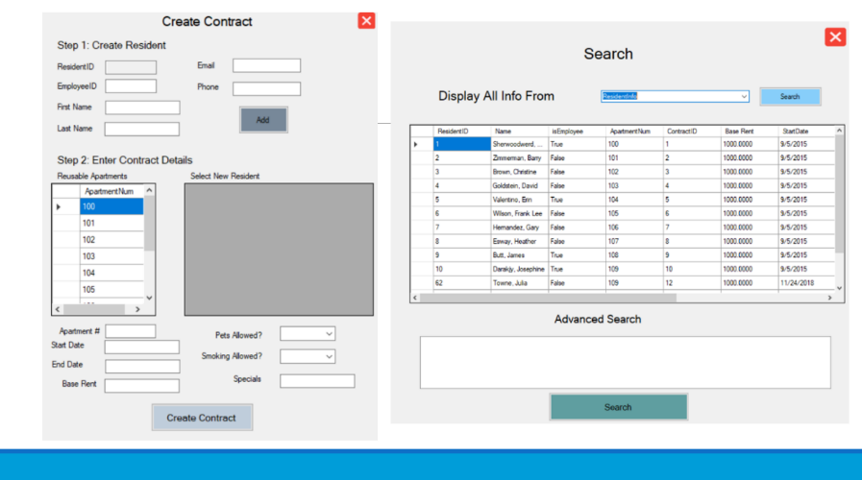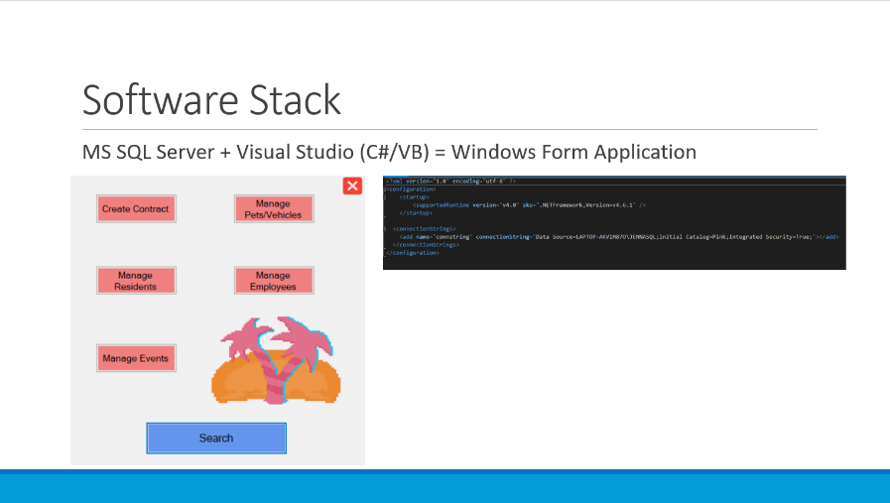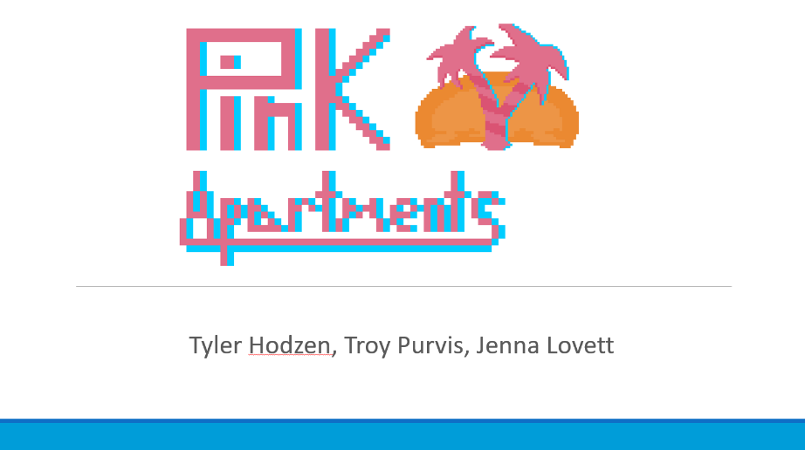**Final Presentation** (Jenna Lovett, Troy Purvis, Tyler Hodzen)

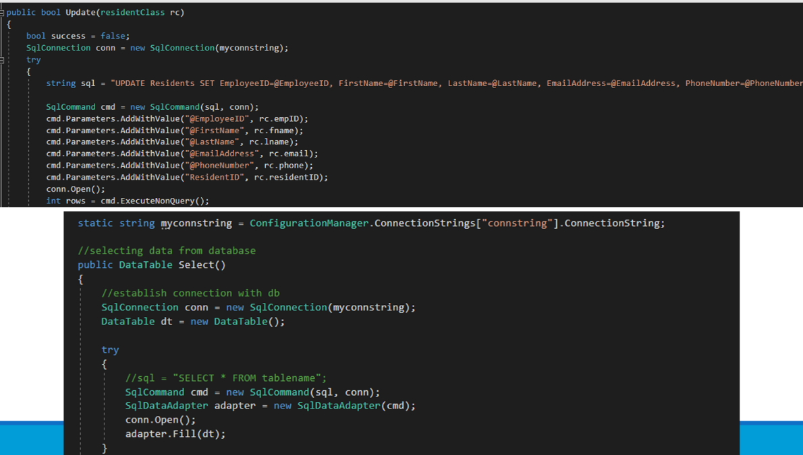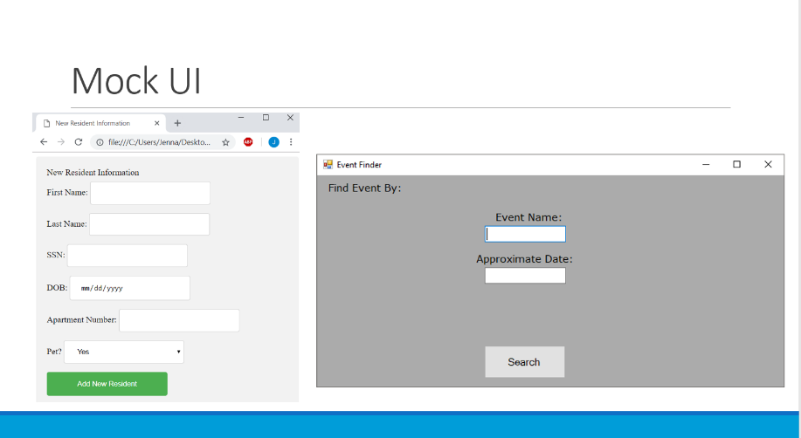

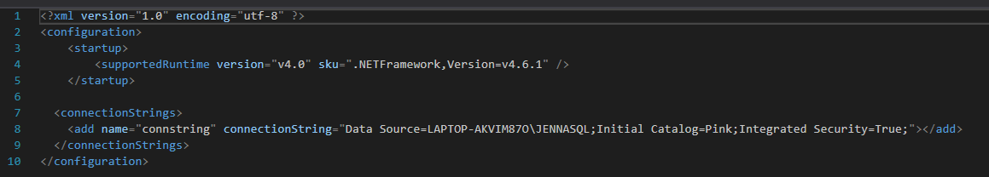**Code Snippets** (Jenna Lovett, Troy Purvis, Tyler Hodzen)

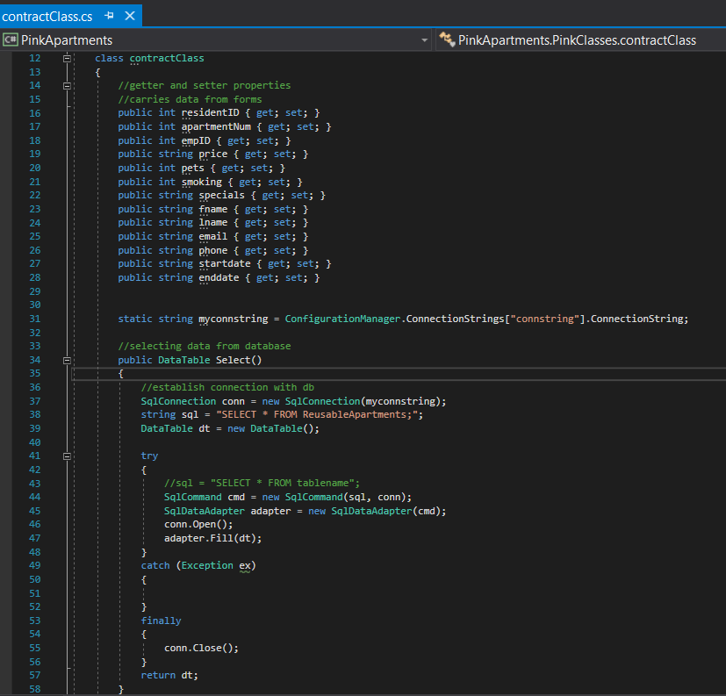In order to run this application on a different machine, the connectionString in the above snippet will need to be changed accordingly. This connection string can be found in MS SQL Server OR in Visual Studio after connecting to the database.

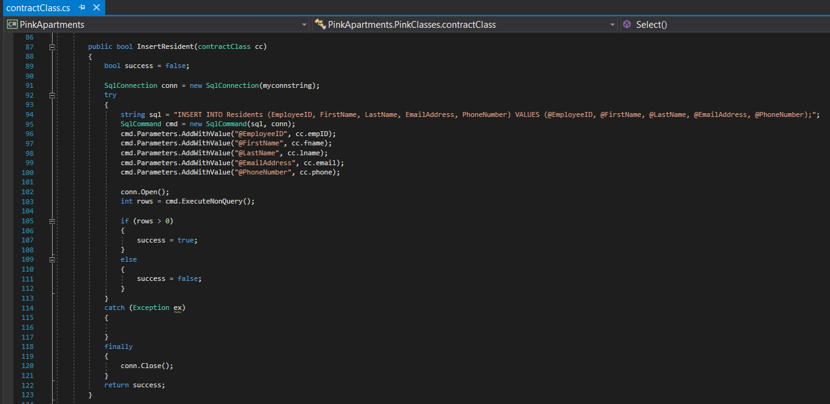

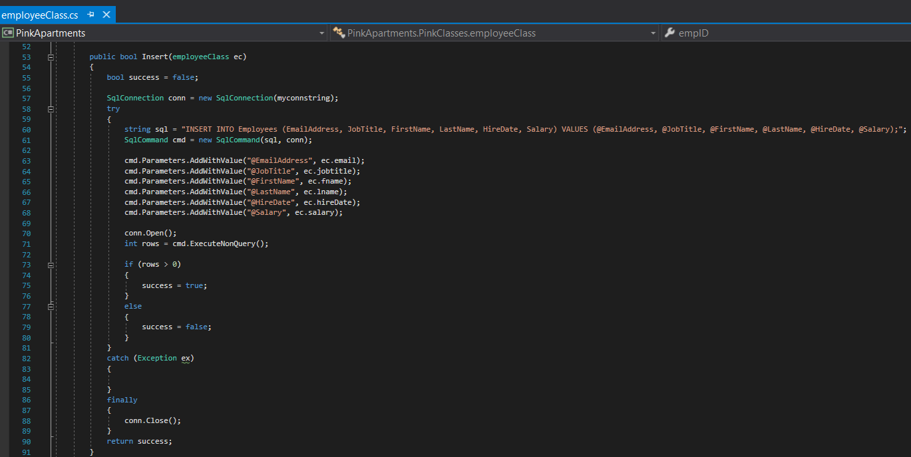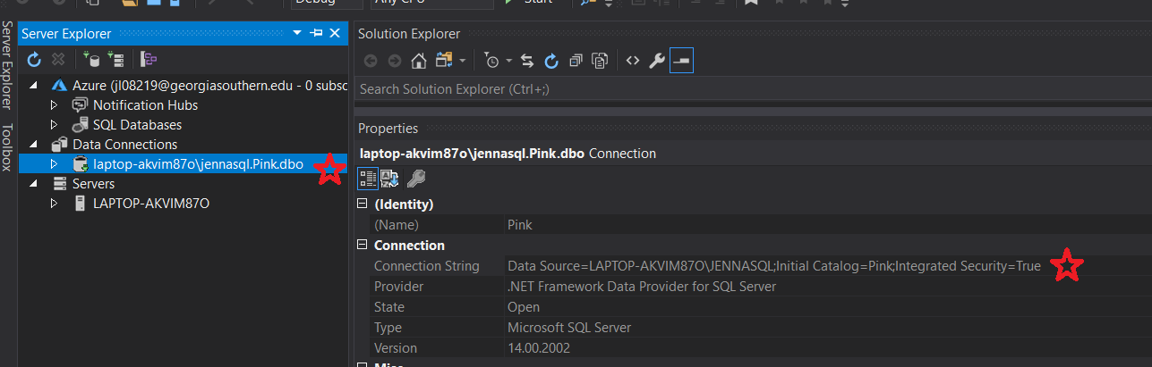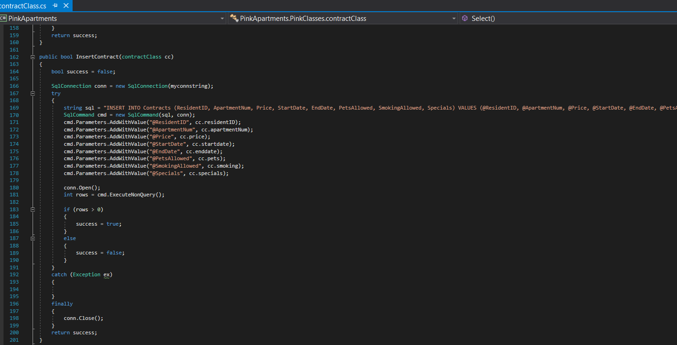

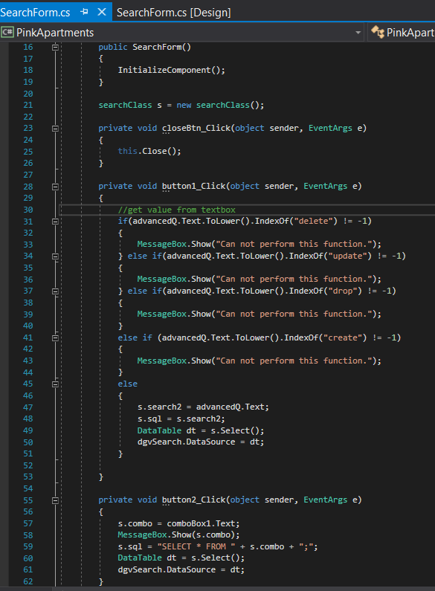

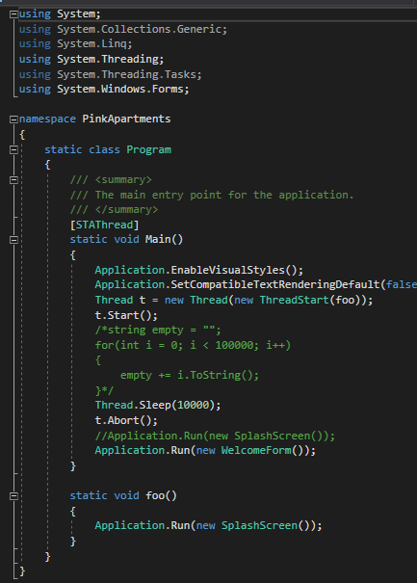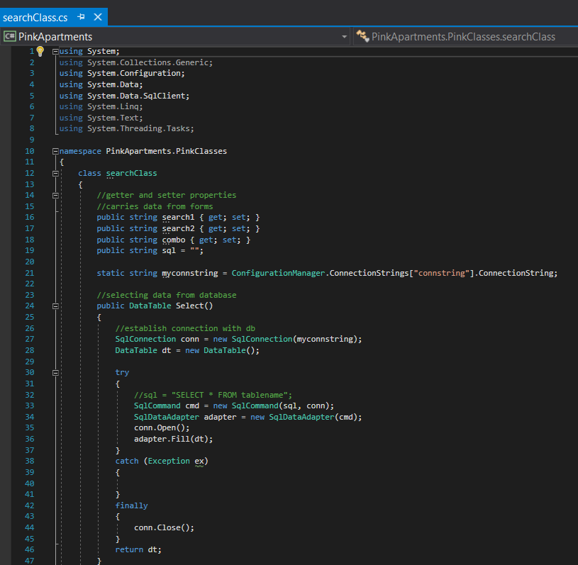This snippet shows search security for our search form. Users will not be able to add, delete, drop, update, or create from the window’s application. (see above)

(Tyler Hodzen)

**SQL Coding Standards** (Jenna Lovett, Troy Purvis, Tyler Hodzen)

During this project, team members will NOT:

* Use CamelCase naming conventions as this makes it difficult to scan over the query in a quick manner
* Use prefixes such as res_pet or res_vehicle
* Use plurals
* Enforce Object Oriented Design principles

During this project, naming conventions include:

* Ensuring uniqueness of names
* Capitalizing all reserved keywords (SELECT instead of select)
* Only use letters, numbers, and keep underscores to a minimum
* Avoid abbreviations
* Use singular name for columns
* DO NOT use ID for a primary key name in ANY table
* DO NOT name a column the same name as the table
* DO NOT concatenate table names

Aliasing

* Use the AS keyword when aliasing
* If using multiple aliases for one table/column/attribute, append a number to the first letter of that entity

Querying

* Use spaces before and after equals(=) and commas (,) and when using parentheses (‘’)
* Include spaces/newlines before AND/OR
* Use indentation following the SELECT statement for any WHERE, FROM, or GROUP BY clauses

**Functional Requirements** (Jenna Lovett, Troy Purvis, Tyler Hodzen)

* The application must function in a way that provides benefits to leasing office administrators at Pink Plateau Paradise Apartments.
* The search feature will allow end users to choose from an assortment of views or make use of the advanced search functionality by providing actual SQL queries.
* The create contracts feature will allow users to generate contracts for new residents. The create contracts feature will be a step-wise process. A resident must first be created, then the user will provide details regarding the contract, including the apartment number, start date, end date, base rent, so and so forth.
* The manage pets and vehicles feature will allow for the creation and updating of pets and vehicles and to assign both to a specific resident.
* The manage employees feature will allow for the creation and updating of employees.
* The manage residents feature will allow for the creation of a new resident and updating of residents. This feature will allow the user to relate an employee to a resident if said resident is an employee for the apartment complex.
* The apartments table will never be directly accessed by end users. If changes need to be made to the apartment table in the future, users will have to bring in outside resources (IT team) from the property management company.
* The payments table will never be directly accessed, as this table will be used by a futuristic resident portal.
* The search feature will check for malicious queries, such as attempts to manipulate data within the database through SQL injections. This security feature will be tested accordingly.
* The application will be built using Visual Studio 2017, C#, VB to create an Windows form application.
* The database will be built using a script that is hand engineered from a data model. The database will be implemented in Microsoft SQL Server 2017.

**Future Opportunities & Security Concerns** (Jenna Lovett, Troy Purvis, Tyler Hodzen)

* Create a resident portal for residents to request events, pet additions/deletions, vehicle additions/deletions, and payment viewing/actioning. (Jenna Lovett)
* Streamline advanced search functionality to perform searches based off keywords instead of SQL queries. (Troy Purvis)
* Create a web-based application so that data can be accessed online versus on a local machine. This would bring security risks, which would need proper assessment before implementation. This would be necessary for a customer-facing (resident) portal. (Tyler Hodzen)
* Updated Data Model (new RI/attributes) (Jenna Lovett and Tyler Hodzen)
* In a future implementation of the employee/administrator application, we would want to only show the last 4 digits of the Resident’s credit card (and hide all other credit card information) to prevent identity theft (Tyler Hodzen)
* Create a logon for the employee application when viewing credit card information (Troy Purvis)



**References**

Complete YouTube playlist tutorial for creating application: <https://www.youtube.com/watch?v=ApPWGEKFnU4&list=PLBLPjjQlnVXVLh8nQWR9M5ADH1iZ6cX5D>

Make a foreign key a primary key (SQL):

<https://stackoverflow.com/questions/16686575/how-to-make-a-foreign-key-a-primary-key-in-sql-server>

Tips on SQL Coding Standards:

<https://www.sqlstyle.guide/>

Class Textbook

Dr. J’s class notes on Folio